. 
Musical Opposites
Social Narrative



Welcome to the Milwaukee Symphony Orchestra “Musical Opposites” Concert!

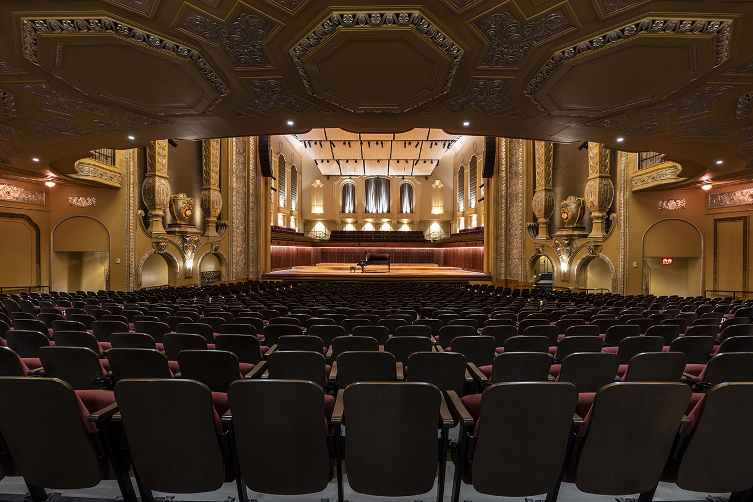

Before the concert begins, I will find my seat with my school in Allen-Bradley Hall!



Assistant Conductor Ryan Tani will be our maestro for today’s performance.





The sounds the orchestra makes will sometimes be loud.

Even though the sounds can be loud and can feel scary, none of the noises can hurt me.

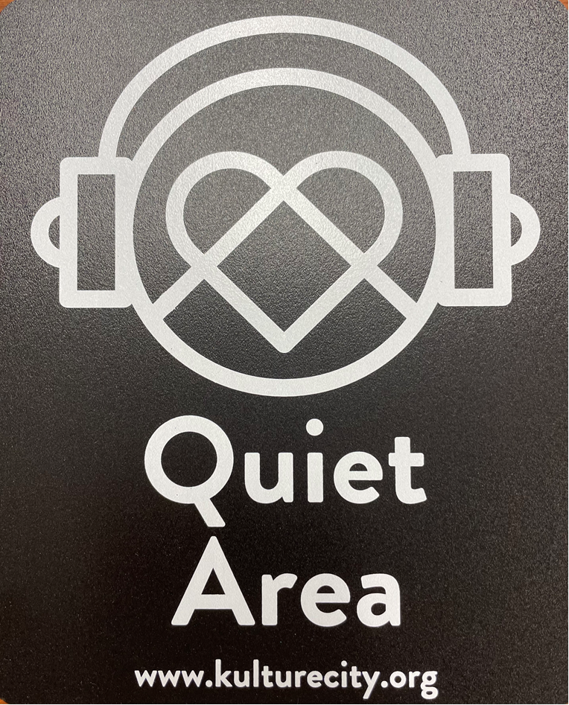
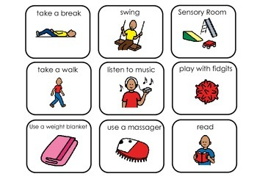

If I need to take a break, I can leave and come back at any time.


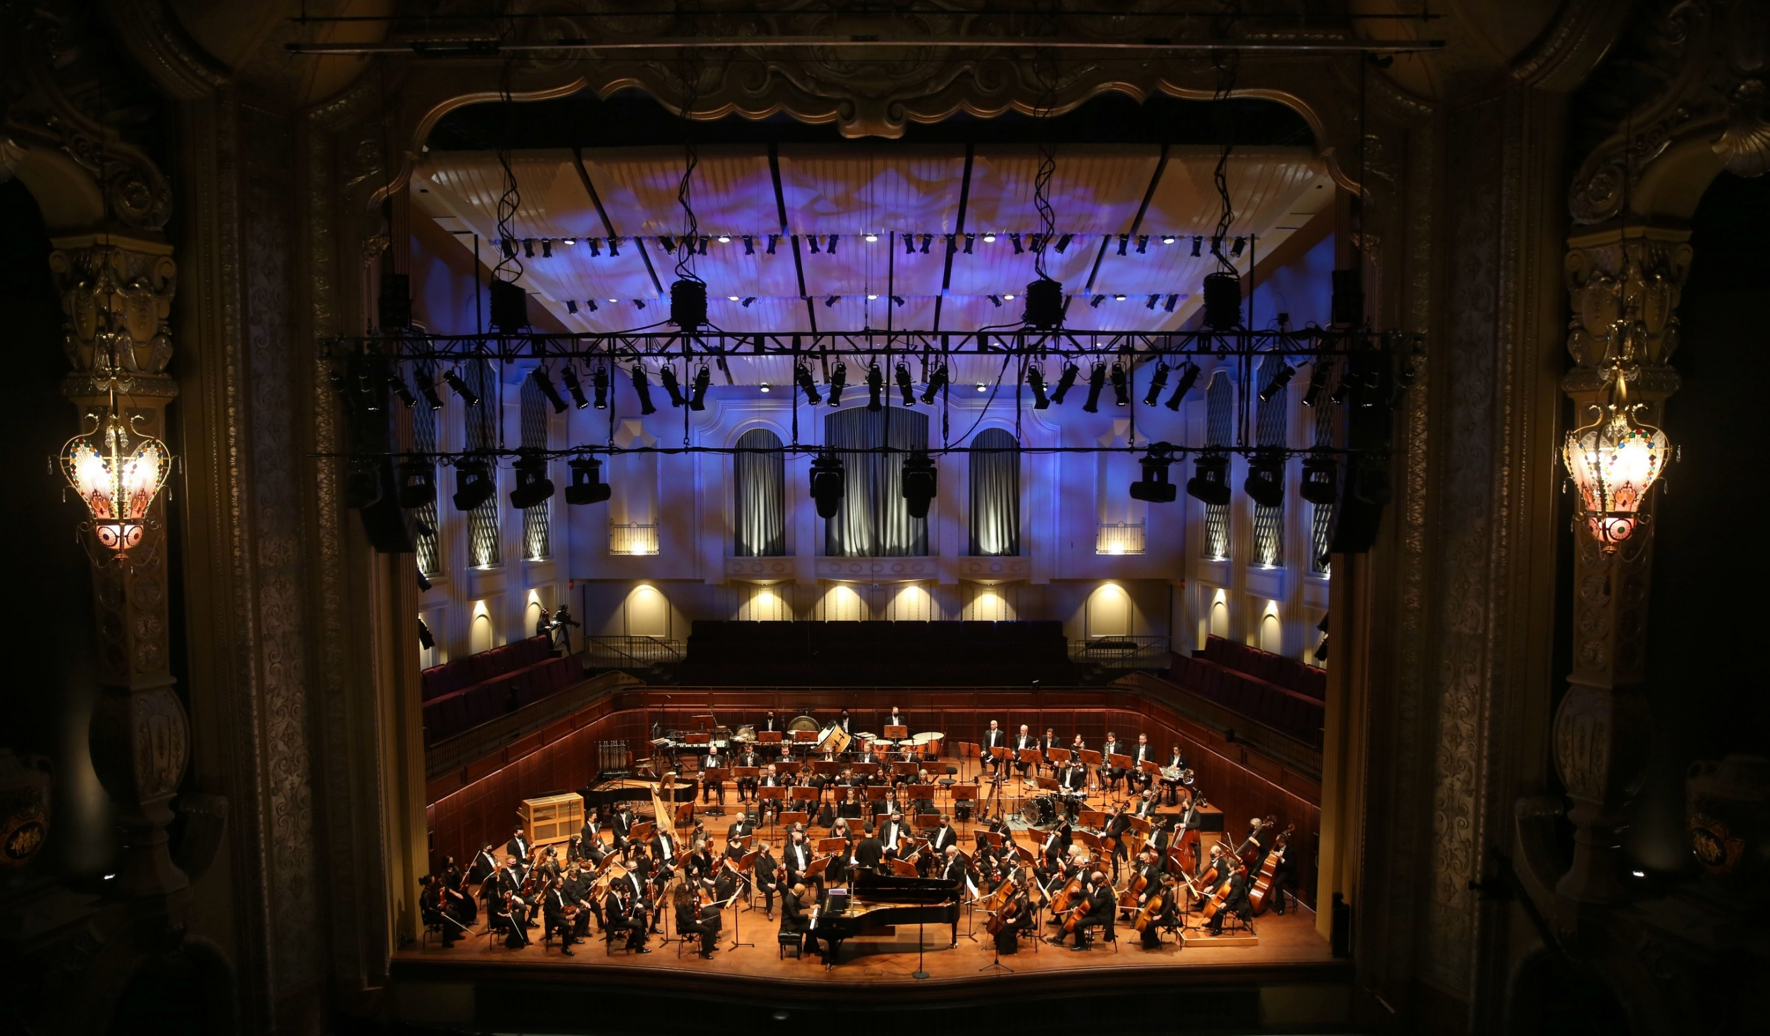
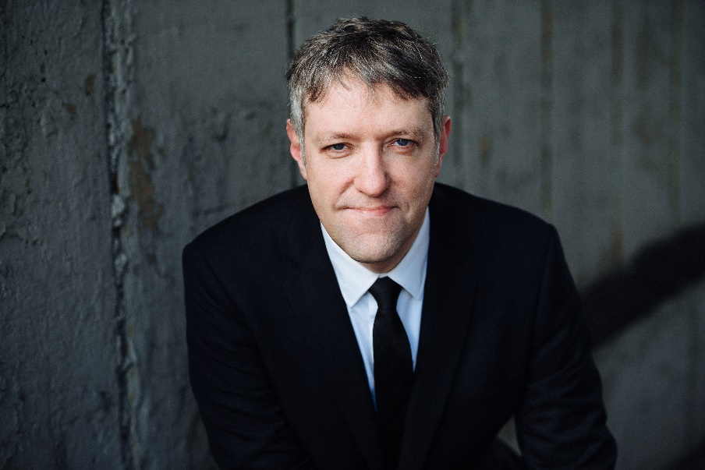

Conductor Ryan and the orchestra will perform “Can-can” from Orpheus in the Underworld by Jacques Offenbach

(Or-feeus) (Jahk Often-bahk)


Click here to listen to the piece on Spotify.

Conductor Ryan and the orchestra will perform “Tortoises” from Carnival of the Animals
by Camille Saint-Saëns

(Ka-MEEL Say-SOHNS)

Click here to listen to the piece on Spotify.

Conductor Ryan and the orchestra will perform
Fairies and Giants from The Wand of Youth
by Edward Elgar

Click here to listen to the piece on Spotify.

Conductor Ryan and the orchestra will perform the
Allegretto from Symphony No. 7 in A Major by
Ludwig van Beethoven

(Loodvig vahn Bay-toe-ven)

Click here to listen to the piece on Spotify.
Conductor Ryan and the orchestra will perform the
Scherzo from Symphony No. 3 in E-flat major by Ludwig van Beethoven

(Skairt-zo) (Loodvig vahn Bay-toe-ven)

Click here to listen to the piece on Spotify.


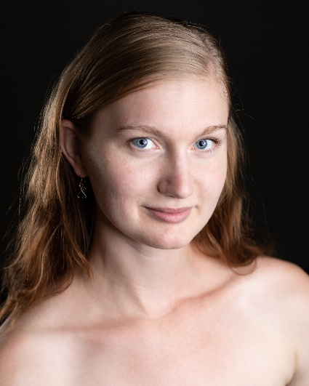

Conductor Ryan, two dancers, and the orchestra will perform
The Seahorse and the Crab
by Michael Djupstrom

(Dee-up-strum)


When the performance is over, I can use the ASL sign for applause or clap to thank the conductor and the musicians.



I will wait in my seat until it is time for my group to return to school.

When I get home, I can share what I heard and saw at the symphony with my friends and family.

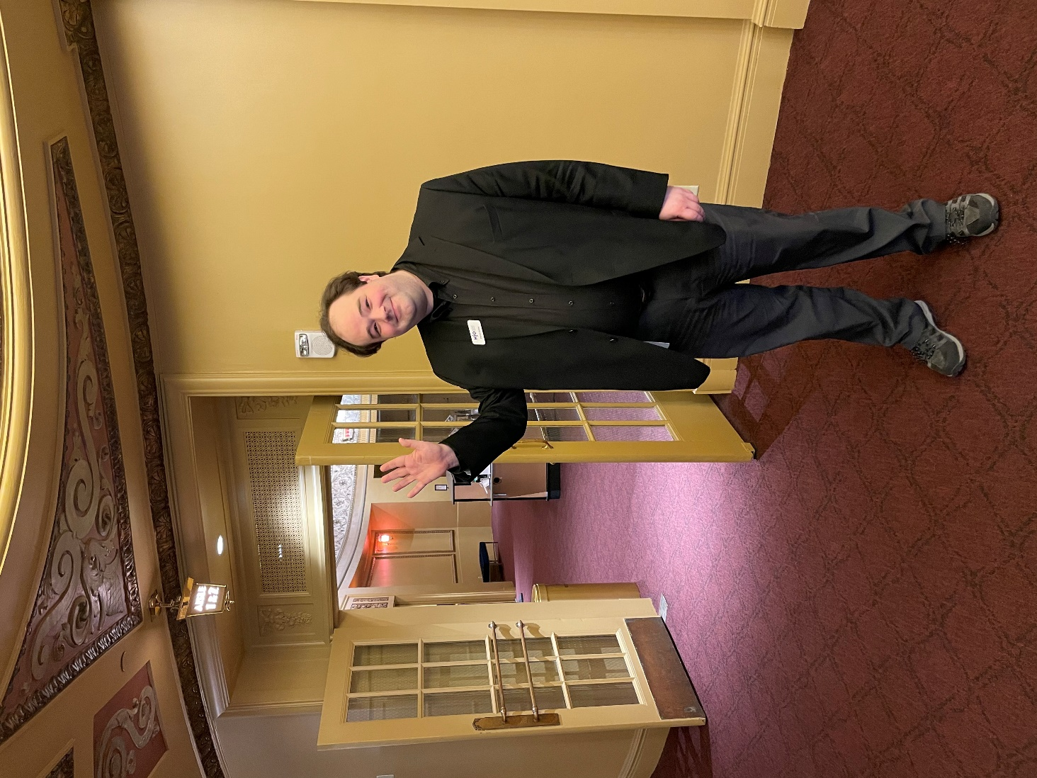

The Milwaukee Symphony Orchestra musicians and staff are so happy you came to the performance today. They look forward to seeing you again!

