Social Story

Musical Vacation!




Welcome to the Milwaukee Symphony Orchestra, Musical Vacation Concert!

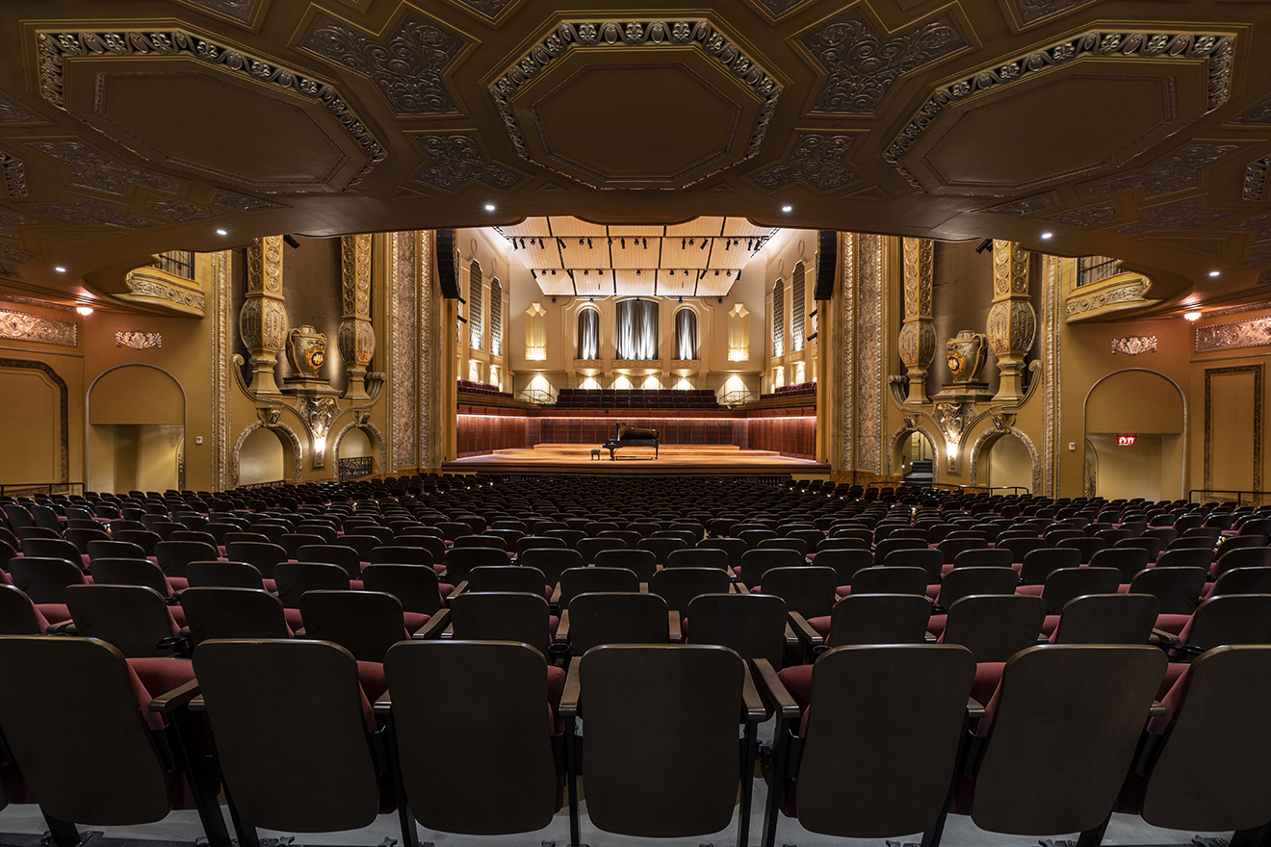

Before the concert begins, I will find my seat in Allen-Bradley Hall!



Assistant Conductor Ryan Tani will be our maestro for today’s performance.



I will see Matthew Huebsch on stage acting as the concert host.





The sounds the orchestra makes will sometimes be loud.

Even though the sounds can be loud and can feel scary, none of the noises can hurt me.

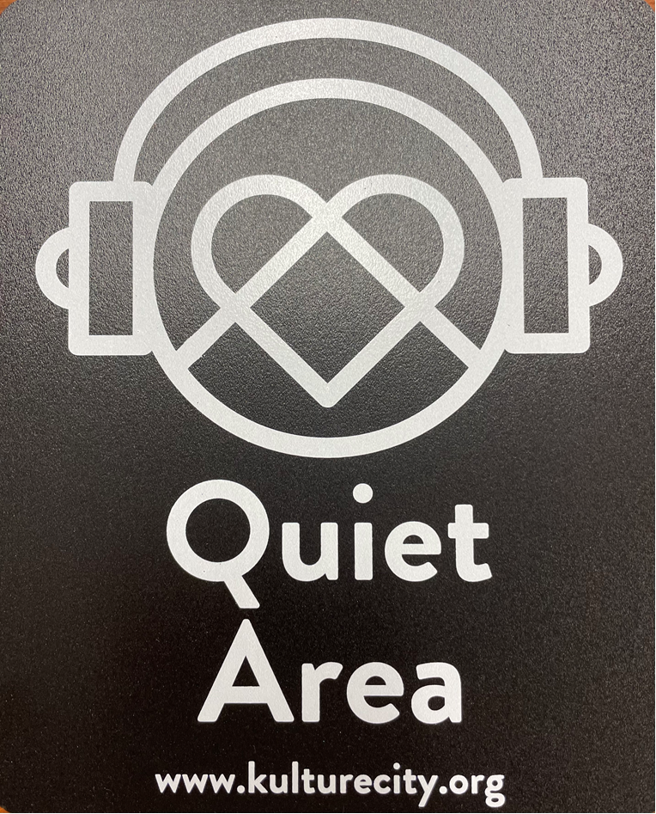
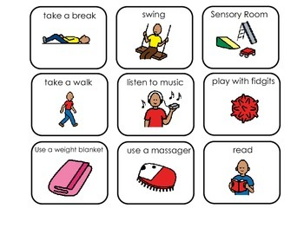

If I need to take a break, I can leave and come back at any time.


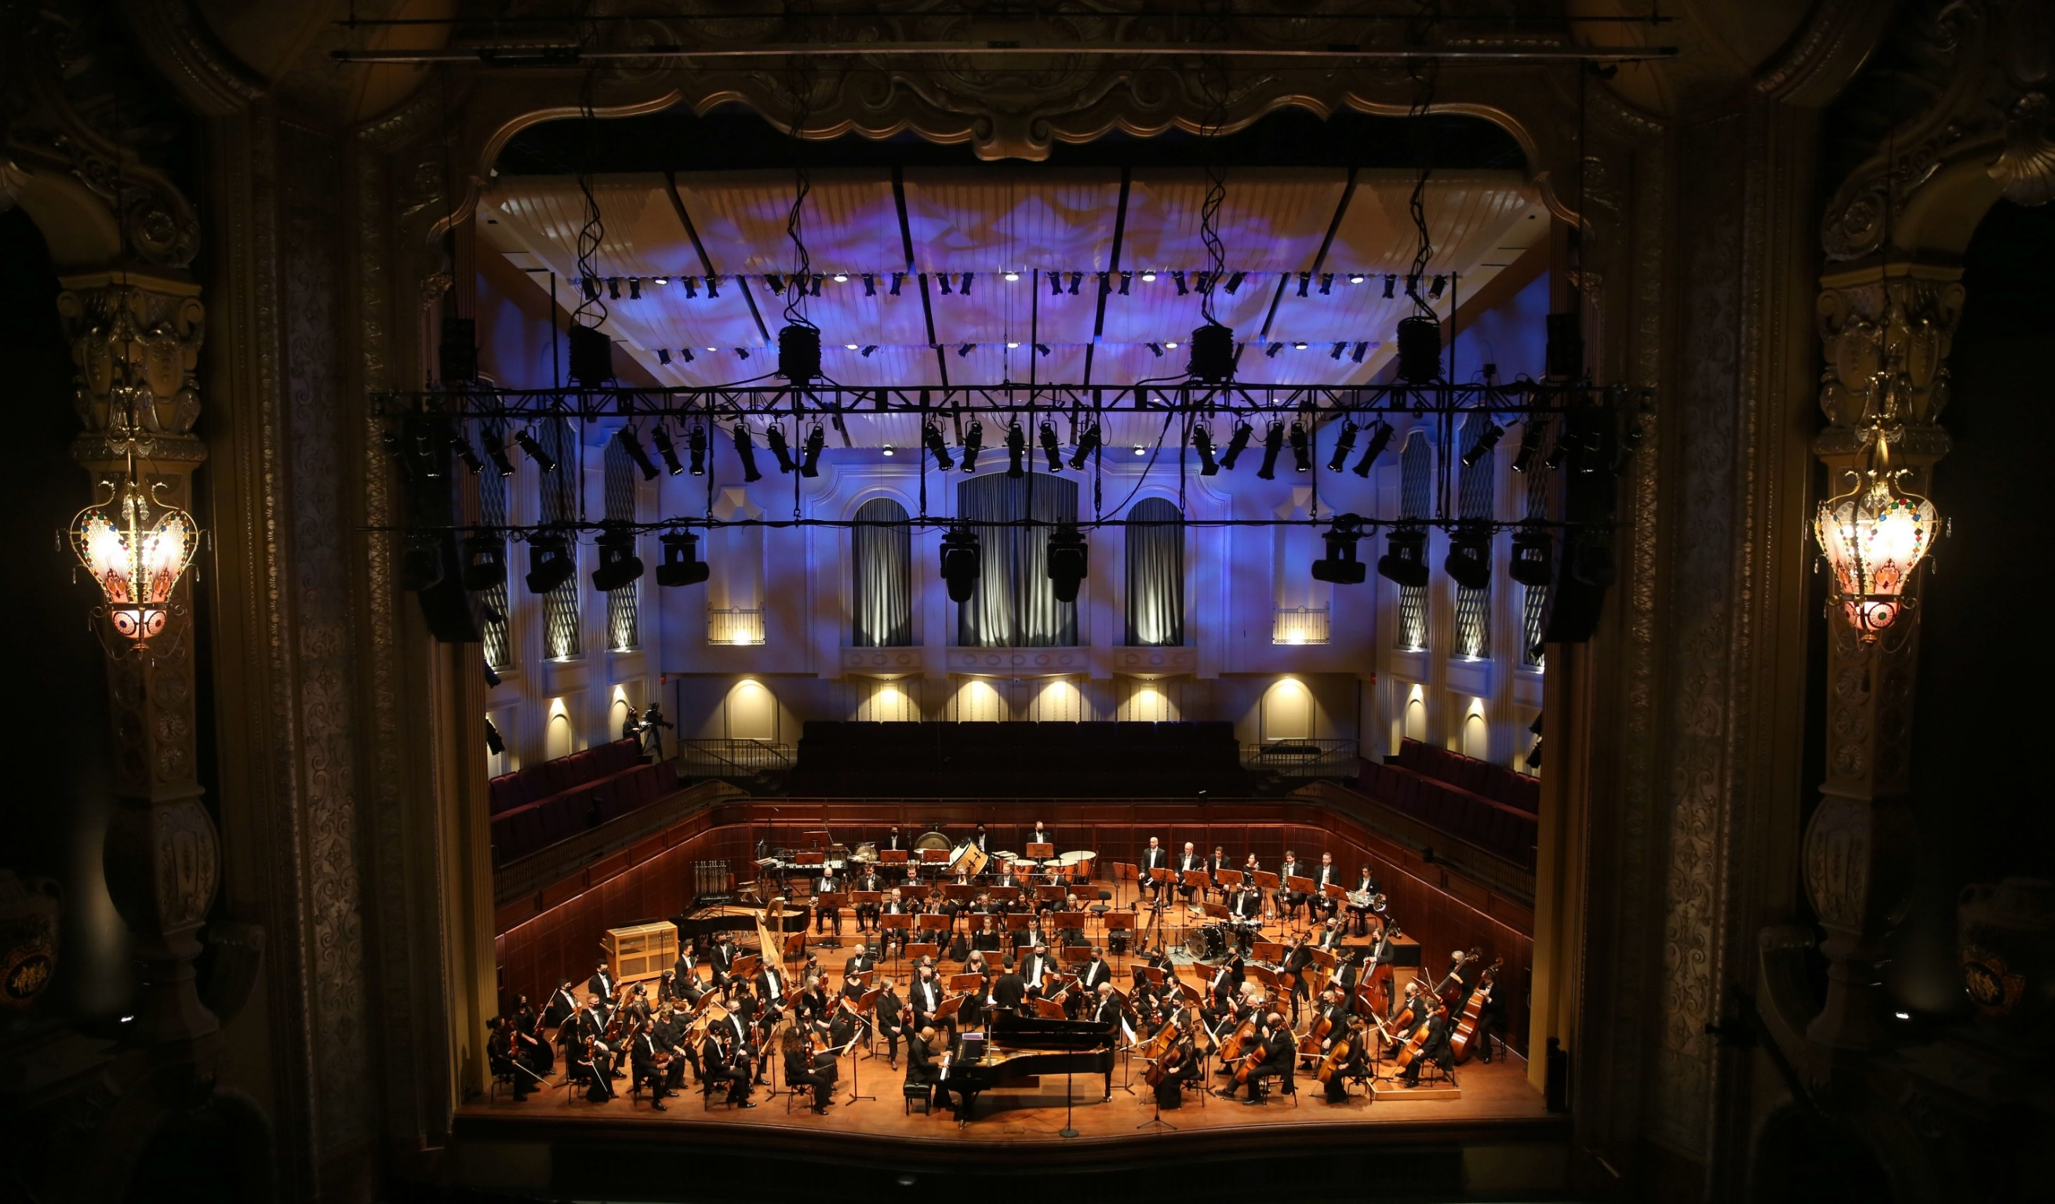
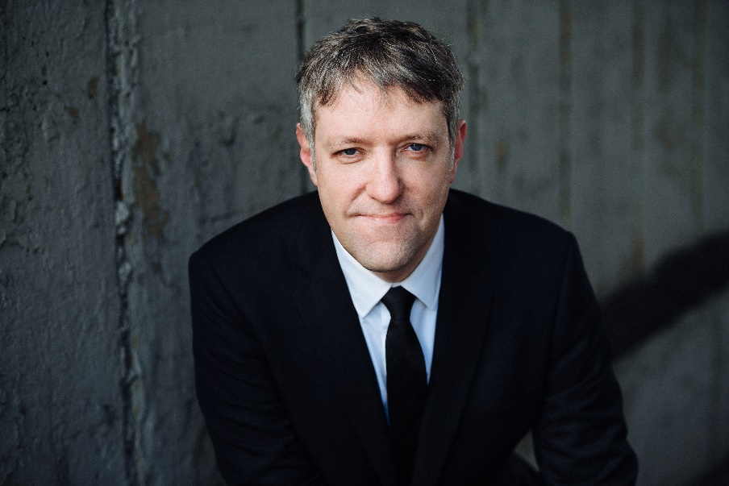

Conductor Ryan and the orchestra will perform “Hoedown” by Aaron Copland.



Click here to listen to the piece on Spotify.


Conductor Ryan and the orchestra will perform “Sunrise” from The Grand Canyon Suite by Ferde Grofé

Click here to listen to the piece on Spotify.

Conductor Ryan and the orchestra will perform “Married Life” from Up by Micheal Giacchino.

Click here to listen to the piece on Spotify.

Conductor Ryan and the orchestra will perform Malagueña by Ernesto Lecuona.

(mahl-ah-Gwain-ya) (ehr-Nest-oh leh-Quo-nah)

Click here to listen to the piece on Spotify.

Conductor Ryan and the orchestra will perform Mov. 1 of Symphony No. 6 in F Major by Ludwig van Beethoven

(Lood-vig vahn Bay-toe-ven)

Click here to listen to the piece on Spotify.

Conductor Ryan and the orchestra will perform the Overture to West Side Story by Leonard Bernstein.

Click here to listen to the piece on Spotify.

Conductor Ryan and the orchestra will perform selections from Frozen by Kristen Anderson-Lopez and Robert Lopez.

Click here to listen to the piece on Spotify.
Conductor Ryan and the orchestra will perform “On Wisconsin!” by William T. Purdy

(Lood-vig vahn Bay-toe-ven)

Click here to listen to the piece on Spotify.



When the performance is over, I can use the ASL sign for applause or clap to thank the conductor and the musicians.

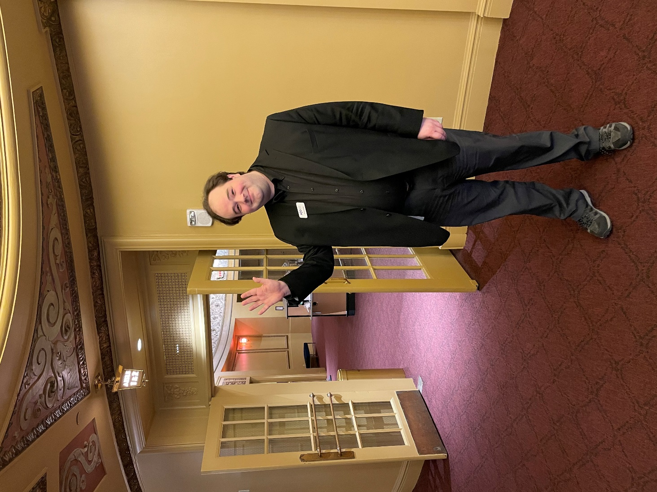

The Milwaukee Symphony Orchestra musicians and staff are so happy you came to the performance today. They look forward to seeing you again!

