Journey of Imagination

Social Narrative



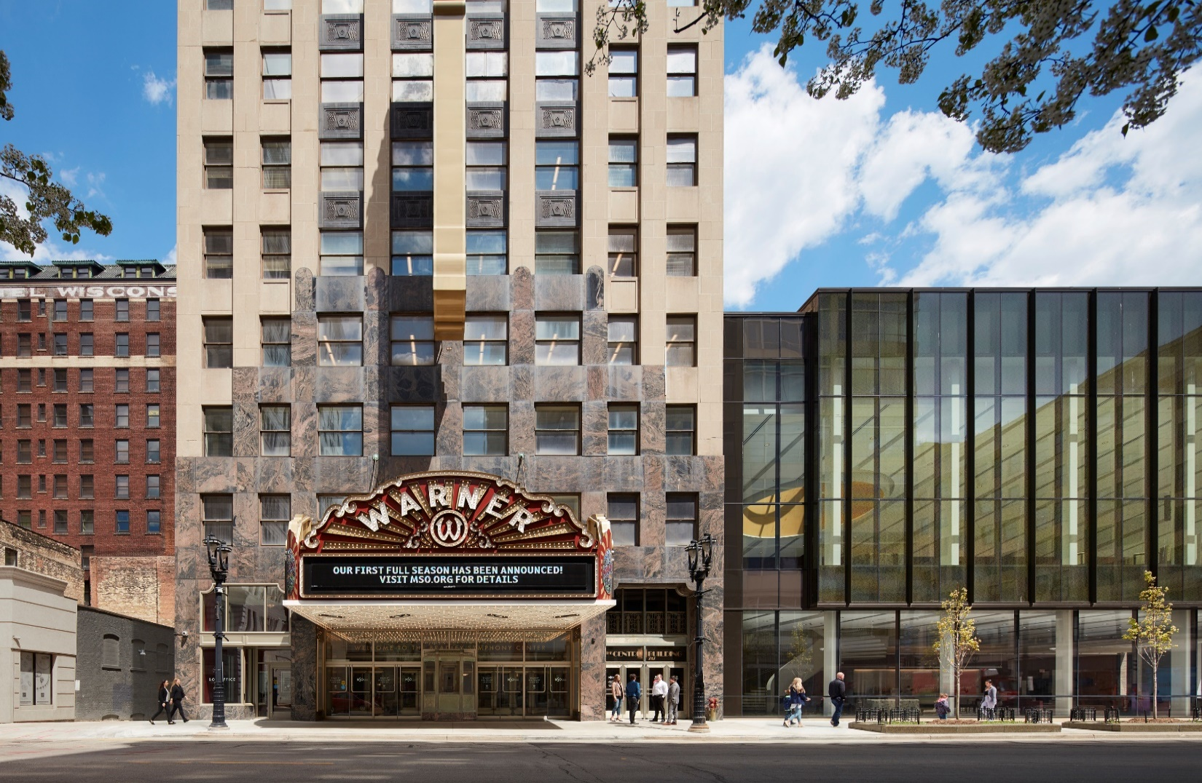

Welcome to the Milwaukee Symphony Orchestra Journey of Imagination Concert!

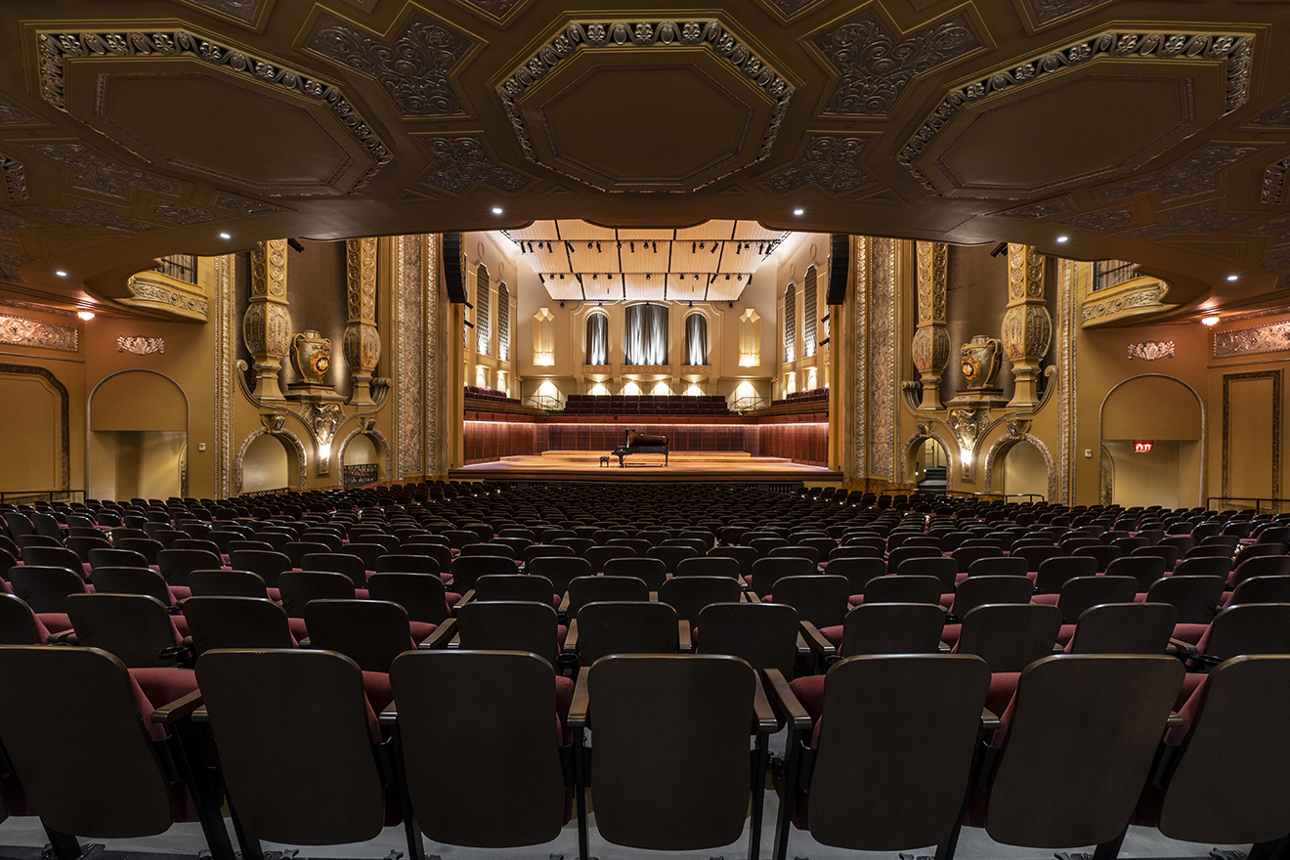

Before the concert begins, I will find my seat with my school in Allen-Bradley Hall!



Assistant Conductor Ryan Tani will be our maestro for today’s performance.





The sounds the orchestra makes will sometimes be loud.

Even though the sounds can be loud and can feel scary, none of the noises can hurt me.

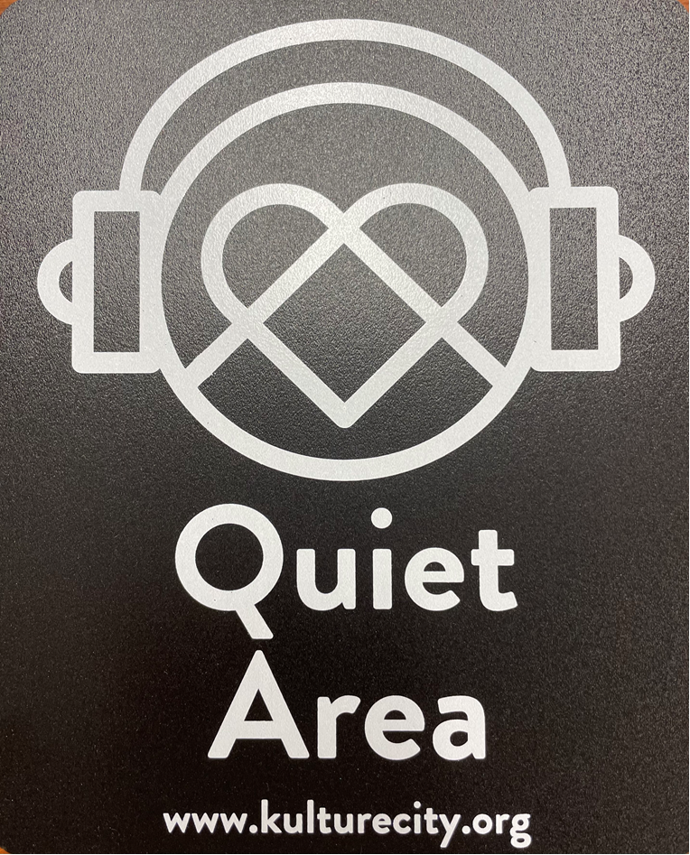
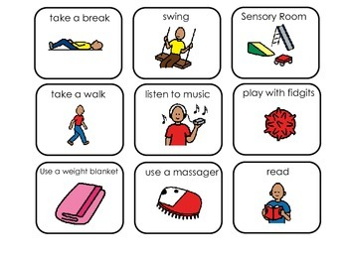

If I need to take a break, I can leave with a chaperone and come back when I’m ready.

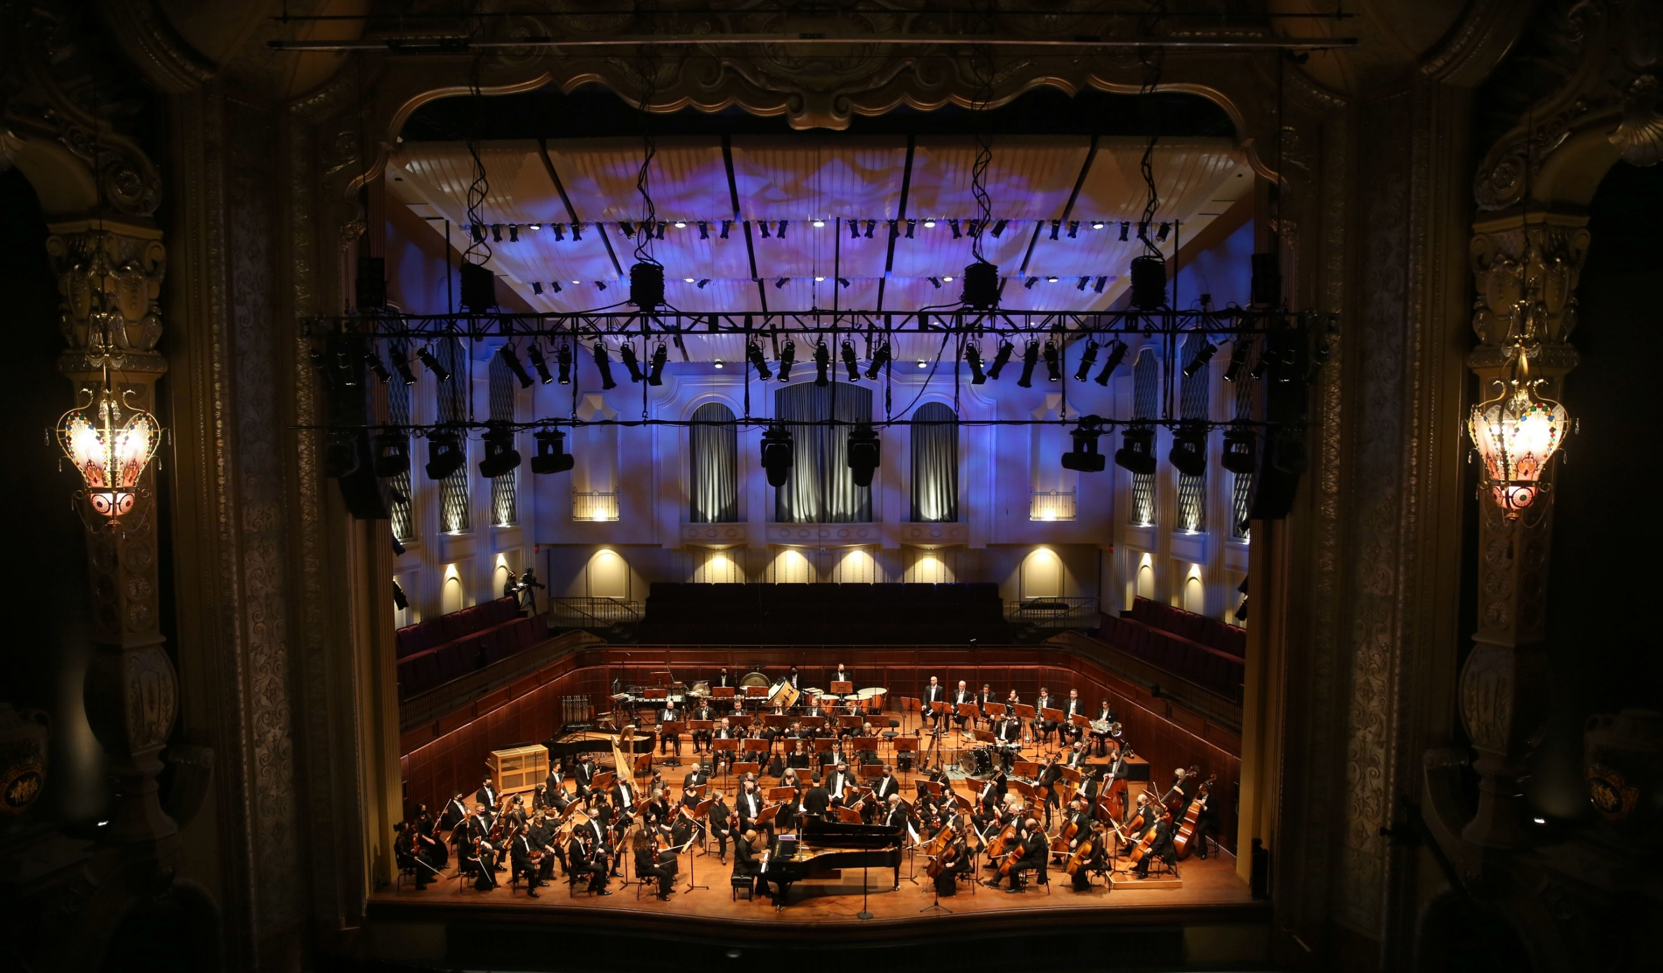

Conductor Ryan and the orchestra will perform
Overture to The Magic Flute by Wolfgang Amadeus Mozart

(vulf-gang ah-ma-day-us moh-tzart)


Click here to listen to the piece on Spotify.
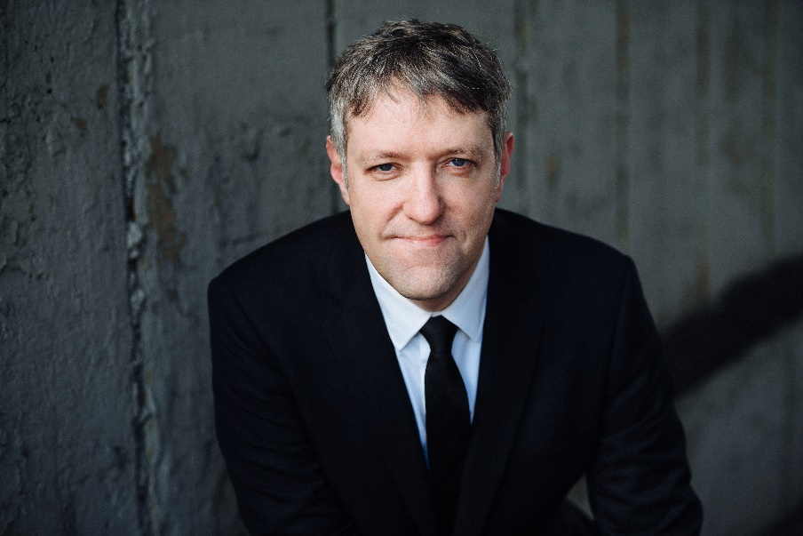
Conductor Ryan and the orchestra will perform a section of
Scheherazade by Nikolai Rimsky-Korsakov

(shuh-hair-eh-zahd) (nee-kol-ai rim-skee core-sah-kahv)

Click here to listen to the piece on Spotify.

Conductor Ryan and the orchestra will perform
Kauyamari by Gabriella Ortiz

(kow-you-mah-ree)

Click here to listen to the piece on Spotify.

Conductor Ryan and the orchestra will perform
Prelude to the Afternoon of a Faun by Claude Debussy

(klahd deh-bew-see)

Click here to listen to the piece on Spotify.
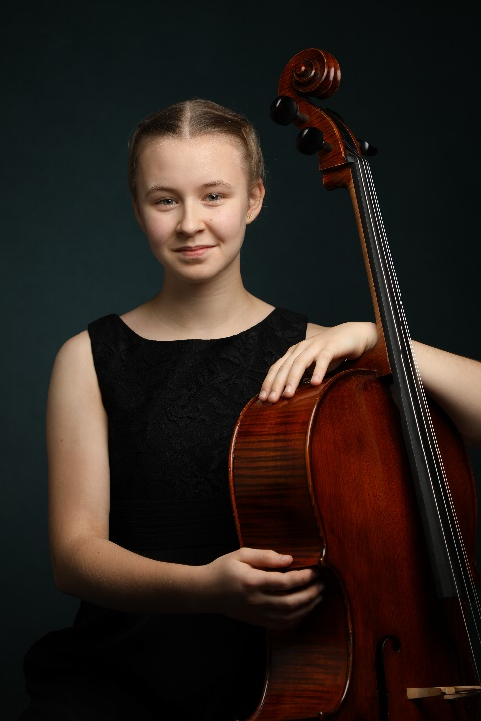
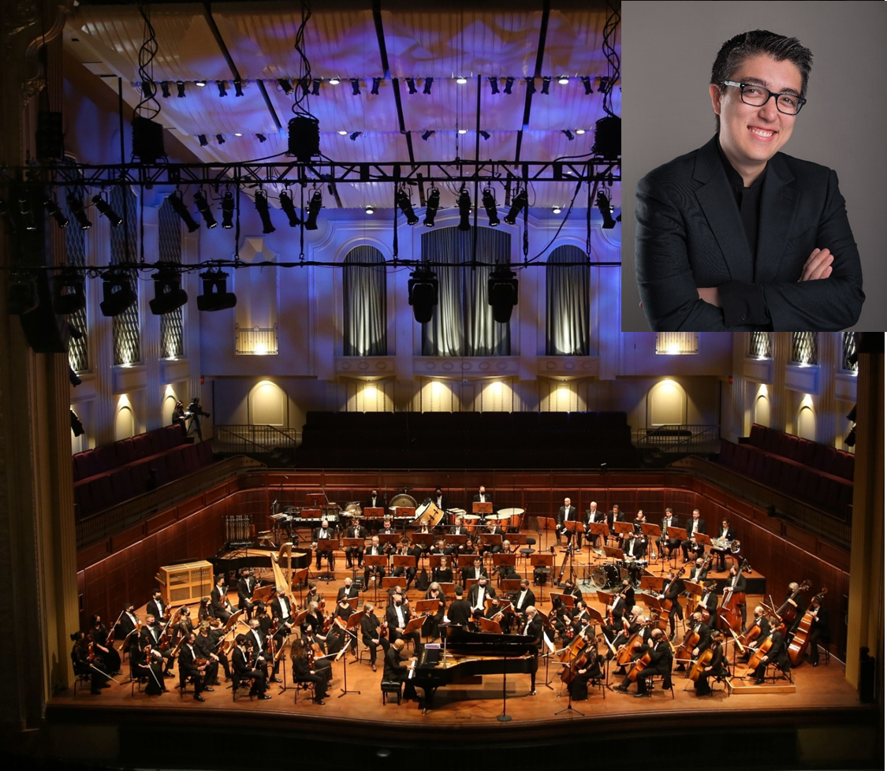

Conductor Ryan, Katarina Kenney, and the orchestra will perform
Pezzo Capriccioso by Piotr Ilych Tchaikovsky.

(pet-zo kah-pri-chi-oh-so) (pea-oh-ter il-ee-ich chai-kahf-skee)
Click here to listen to the piece on Spotify.

Conductor Ryan and the orchestra will perform “In the Hall of the Mountain King” by Edvard Grieg

(ED-vard GREEG)

Click here to listen to the piece on Spotify.

Conductor Ryan and the orchestra will perform
“How Far I’ll Go” from Moana by Lin-Manuel Miranda.

Click here to listen to the piece on Spotify.



When the performance is over, I can use the ASL sign for applause or clap to thank the conductor and the musicians.



I will wait in my seat until it is time for my group to return to school.

When I get home, I can share what I heard and saw at the symphony with my friends and family.

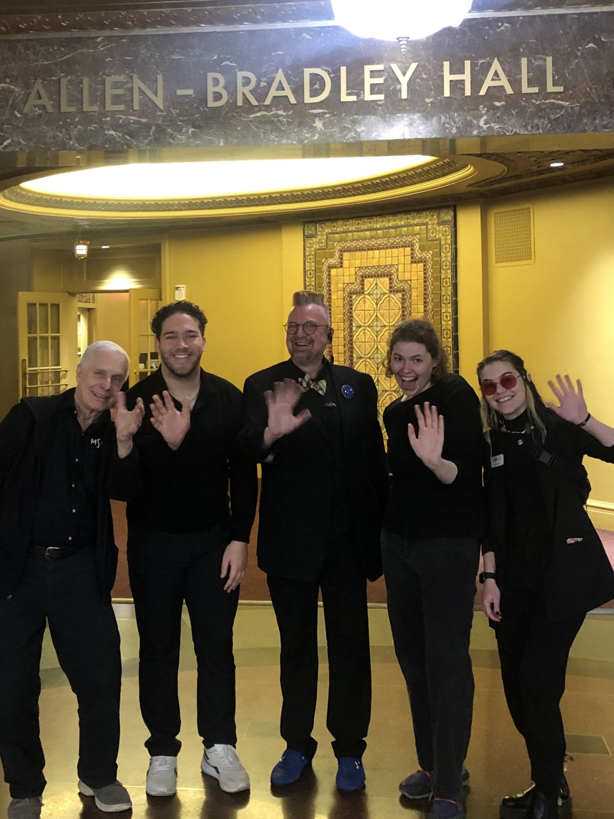

The Milwaukee Symphony Orchestra musicians and staff are so happy you came to the performance today. They look forward to seeing you again!

