
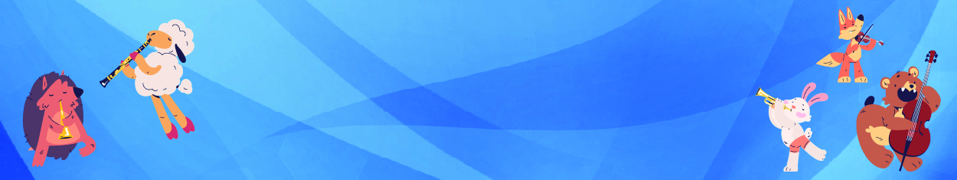
Social Narrative

Musical Zoo

Welcome to the Milwaukee Symphony Orchestra Musical Zoo Concert!

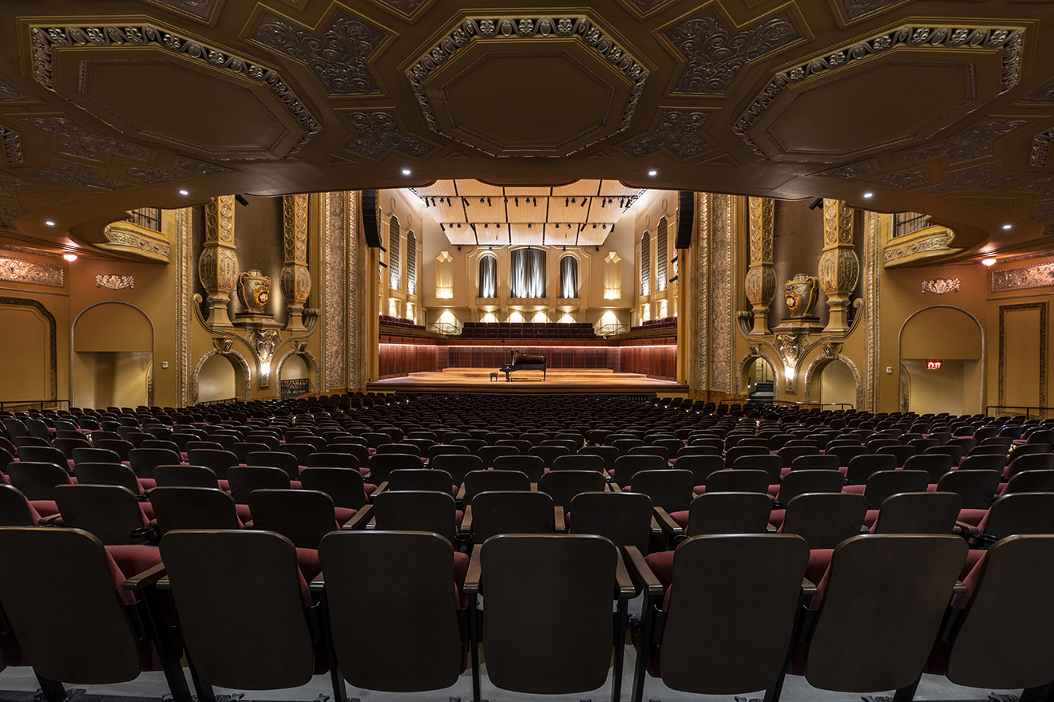

Before the concert begins, I will find my seat with my school in Allen-Bradley Hall!



Assistant Conductor Ryan Tani will be our maestro for today’s performance.



Jim LaBelle will be our narrator for today’s performance.

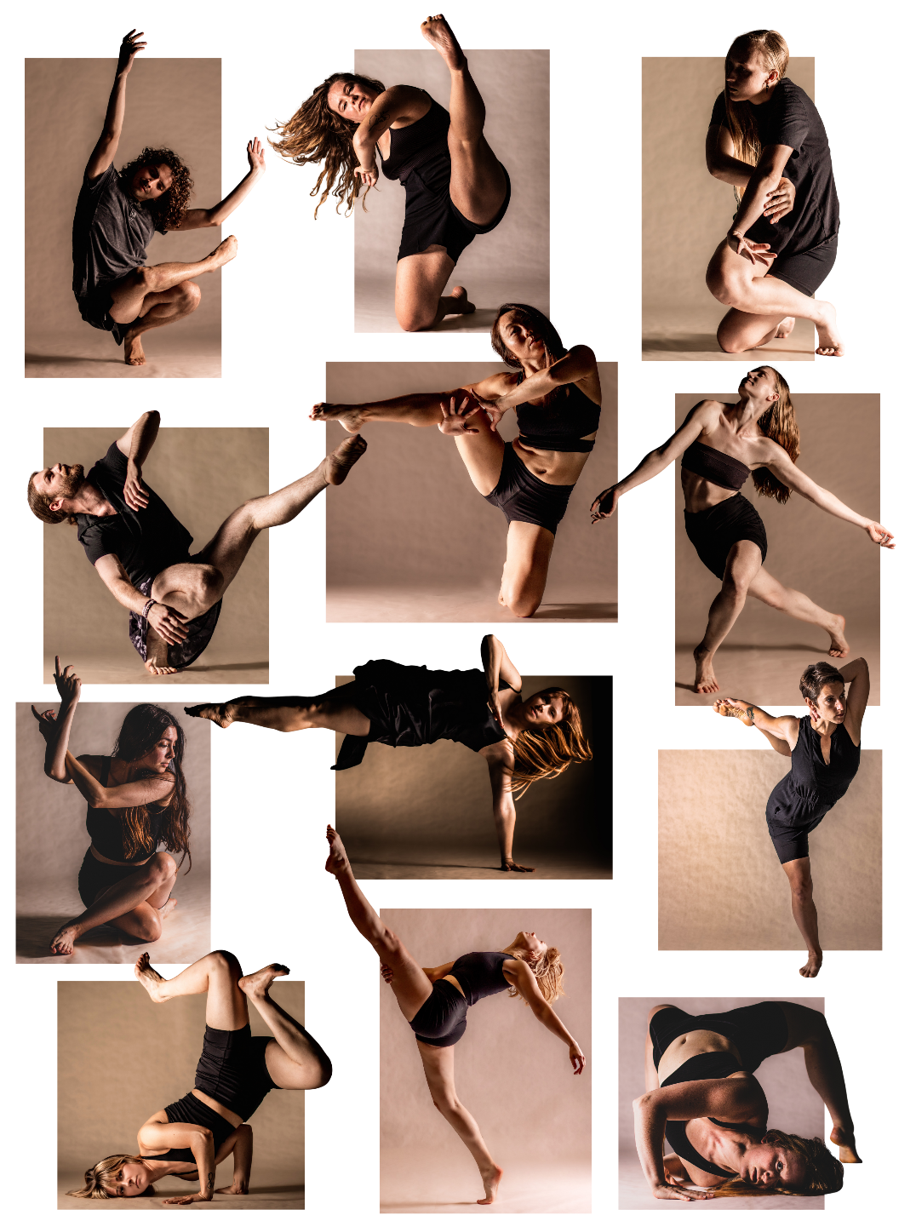

Danceworks MKE will be our guest artists for today’s performance.





The sounds the orchestra makes will sometimes be loud.

Even though the sounds can be loud and can feel scary, none of the noises can hurt me.


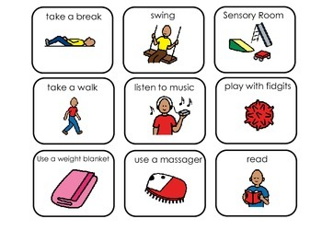

If I need to take a break, I can leave with a chaperone and come back when I’m ready.


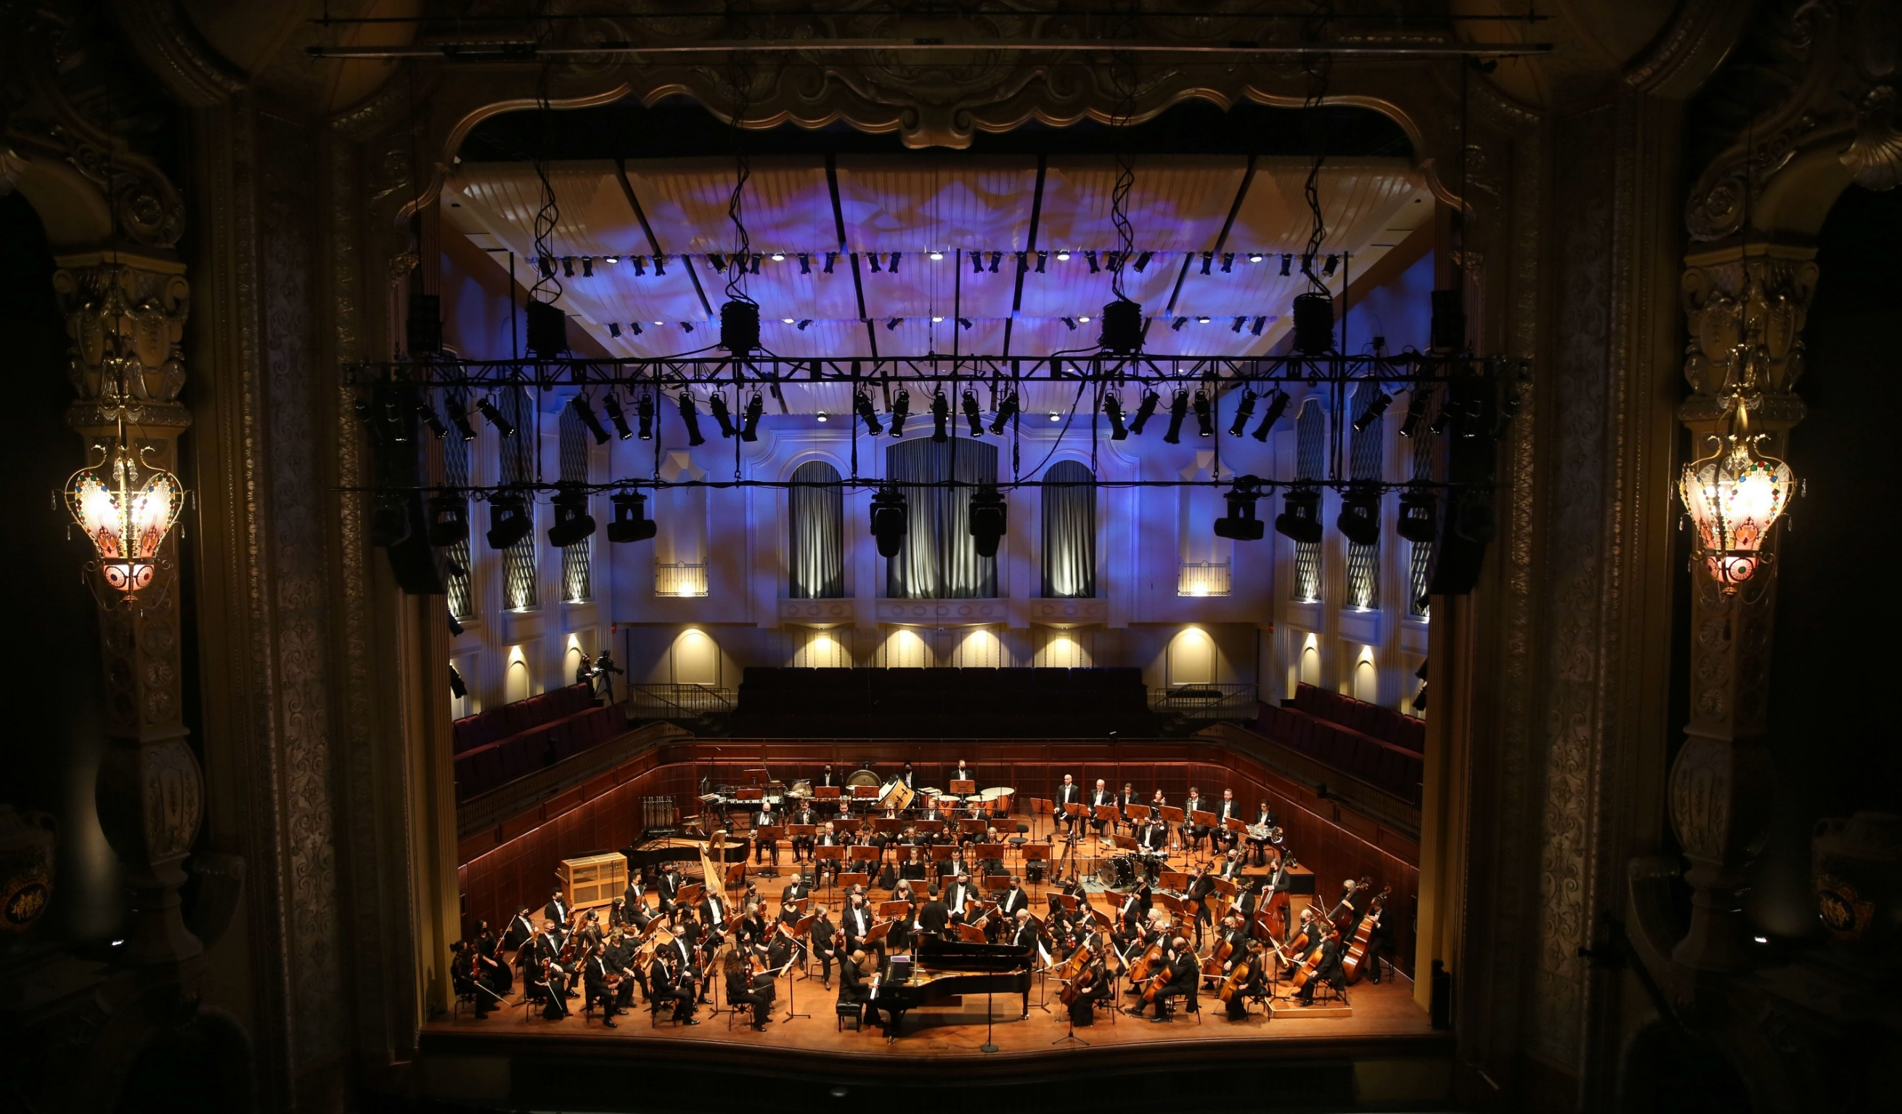

Conductor Ryan, Narrator Jim, and the orchestra will perform Three Fun Fables by Daniel Dorff



Click here to listen to the piece on Spotify.
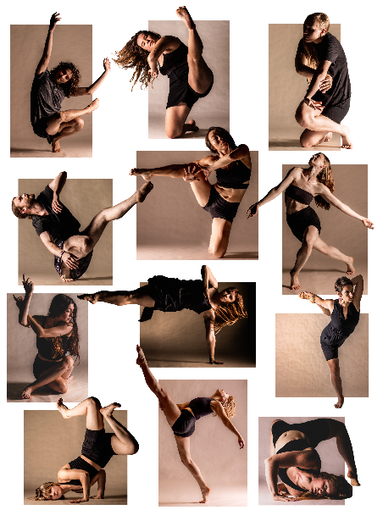
Conductor Ryan, Narrator Jim, Danceworks dancers, and the orchestra will perform Carnival of the Animals by Camille Saint-Saëns

(kah-meal sen-sohn)

Click here to listen to the piece on Spotify.



When the performance is over, I can use the ASL sign for applause or clap to thank the conductor and the musicians.



I will wait in my seat until it is time for my group to return to school.

When I get home, I can share what I heard and saw at the symphony with my friends and family.

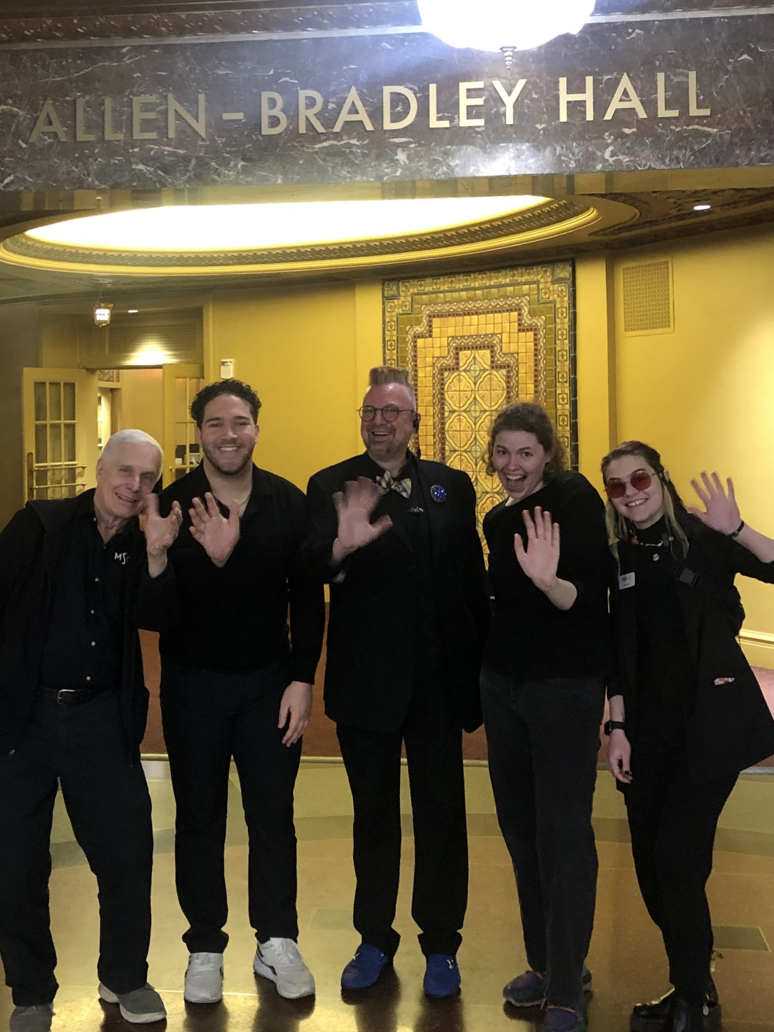

The Milwaukee Symphony Orchestra musicians and staff are so happy you came to the performance today. They look forward to seeing you again!

