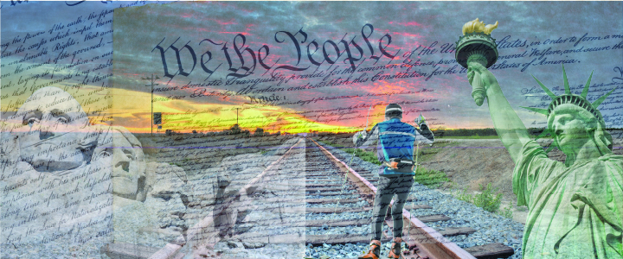
Social Narrative

Trailblazers:
A Celebration of the American Spirit

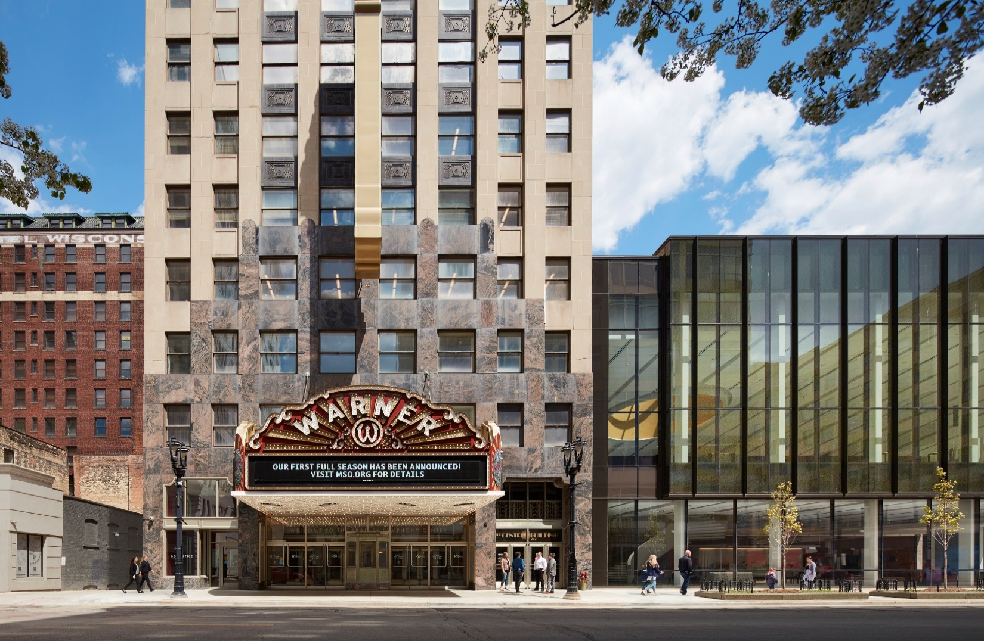

Welcome to the Milwaukee Symphony Orchestra Trailblazers: A Celebration of the American Spirit Concert!

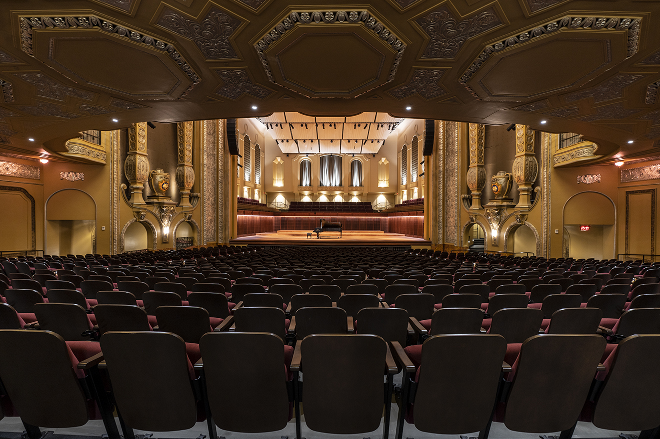

Before the concert begins, I will find my seat with my school in Allen-Bradley Hall!

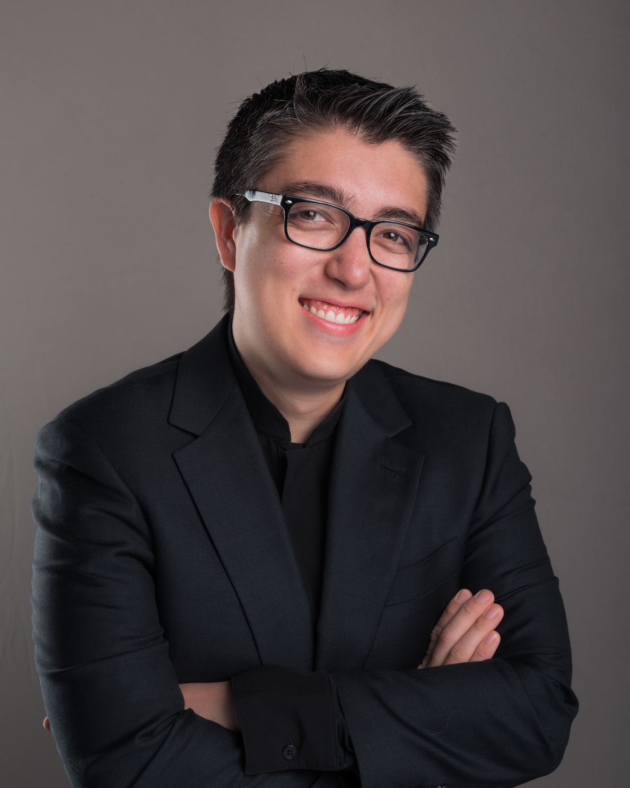

Assistant Conductor Ryan Tani will be our maestro for today’s performance.



Actor Caitlyn Nettesheim will be our host for today’s performance.





The sounds the orchestra makes will sometimes be loud.

Even though the sounds can be loud and can feel scary, none of the noises can hurt me.

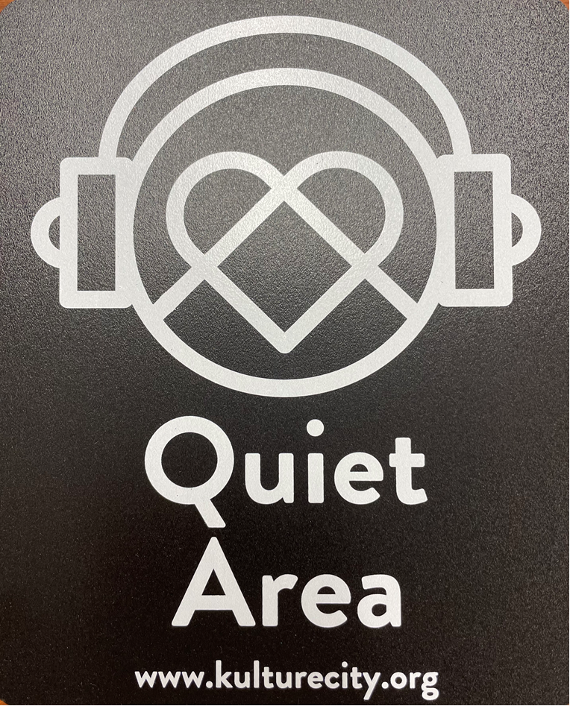
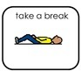

If I need to take a break, I can leave with a chaperone and come back when I’m ready.

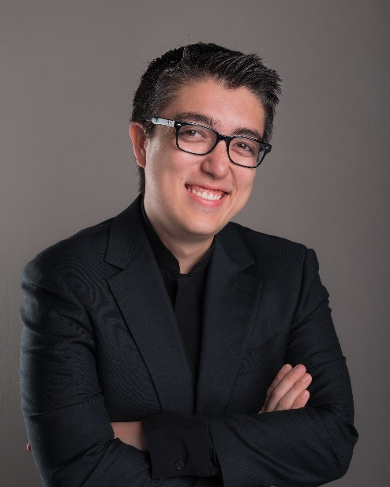
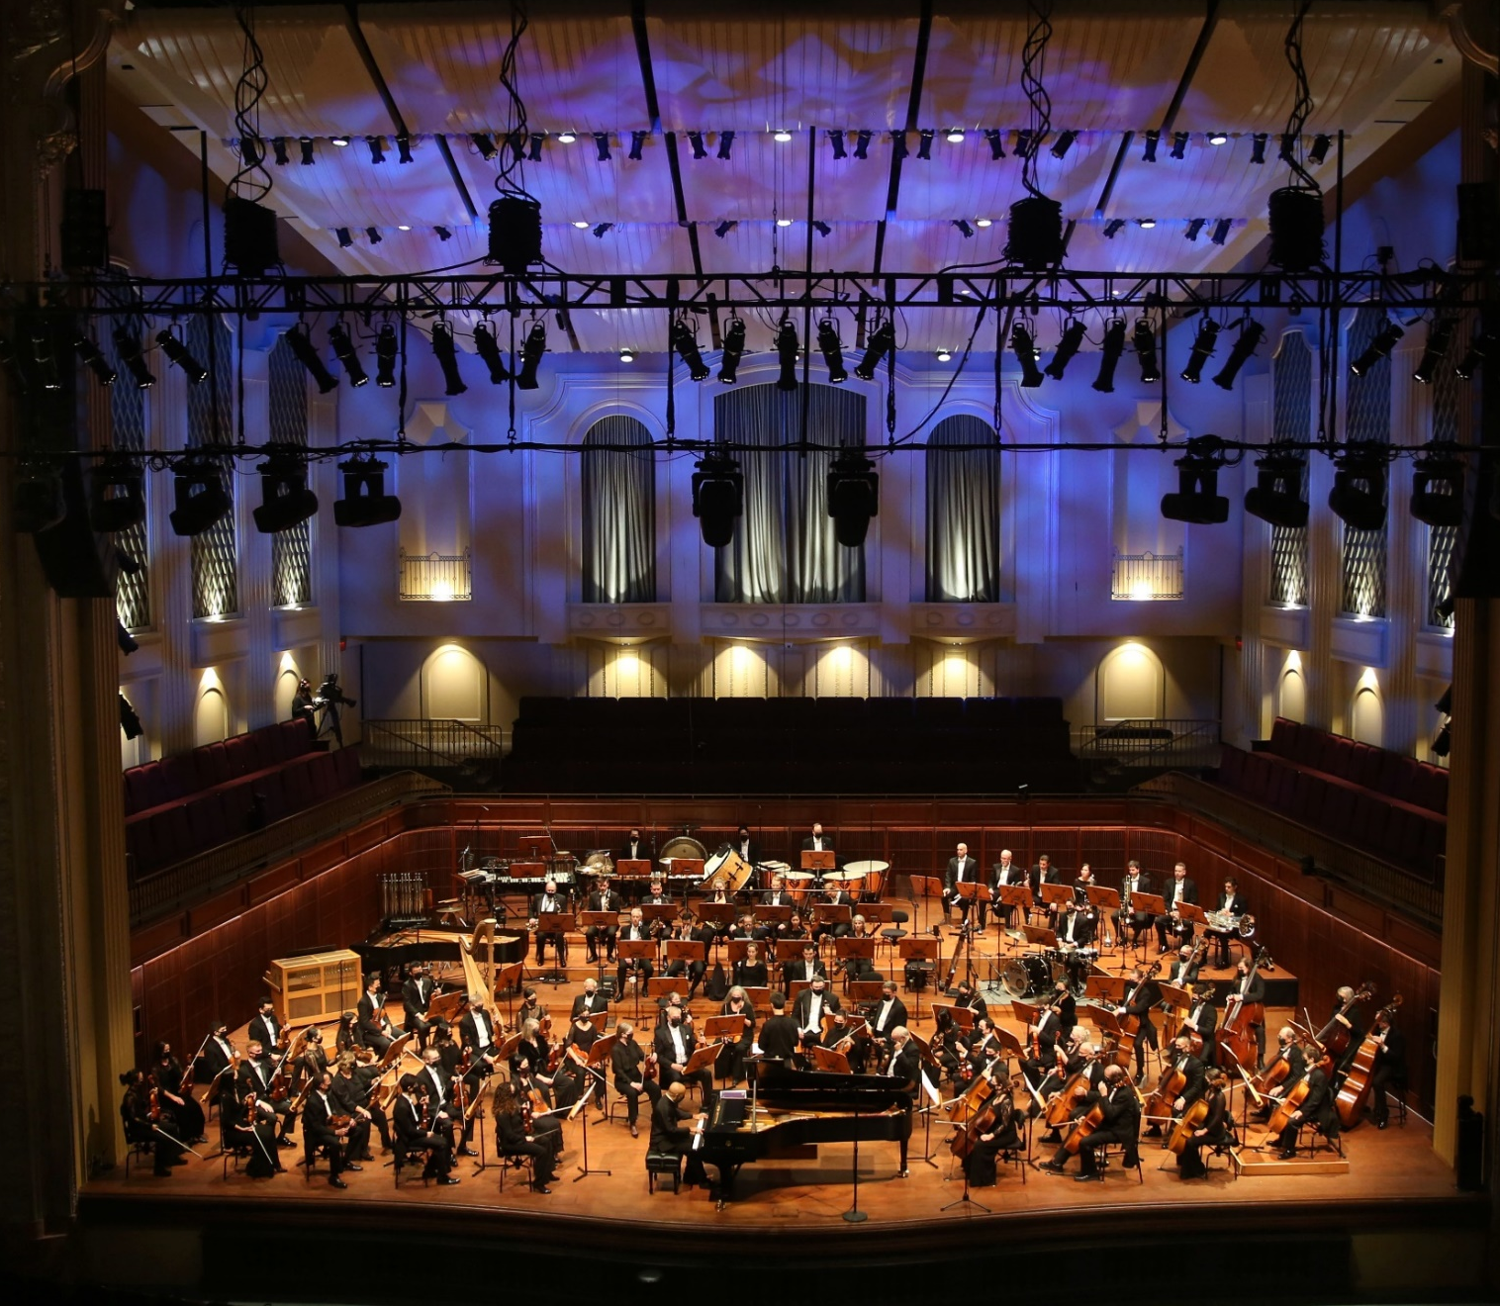

Conductor Ryan and the orchestra will perform
The Entertainer by Scot Joplin

(jaw-plin)


Click here to listen to the piece on Spotify.
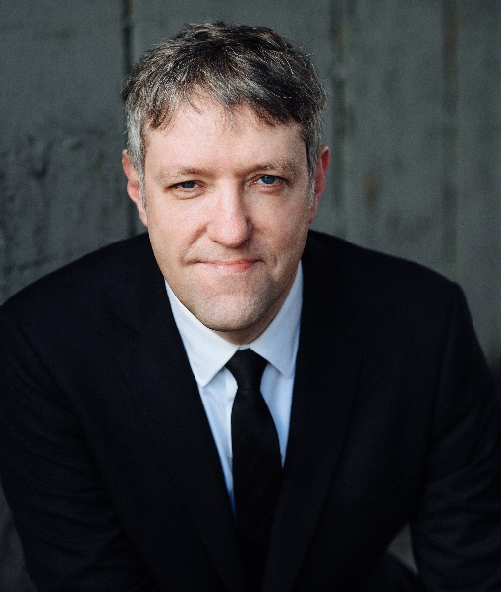

Conductor Ryan and the orchestra will perform John Henry, A Railroad Ballad for Orchestra by Aaron Copland.

(kope-land)

Click here to listen to the piece on Spotify.
Conductor Ryan and the orchestra will perform
“Ring Shout” from Four Black American Dances by Carlos Simon


Click here to listen to the piece on Youtube.

Conductor Ryan and the orchestra will perform “Juba Dance” from Symphony No. 1 in E Minor by Florence Price.

(Joo-bah)

Click here to listen to the piece on Spotify.
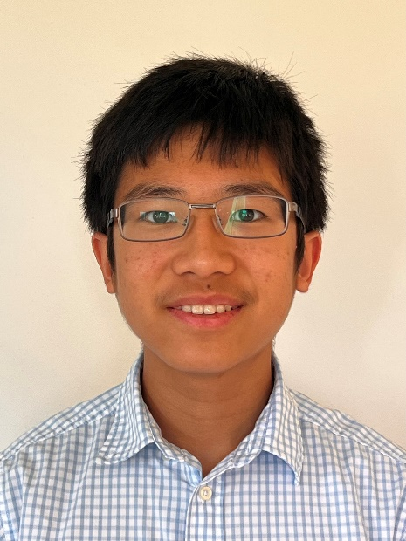
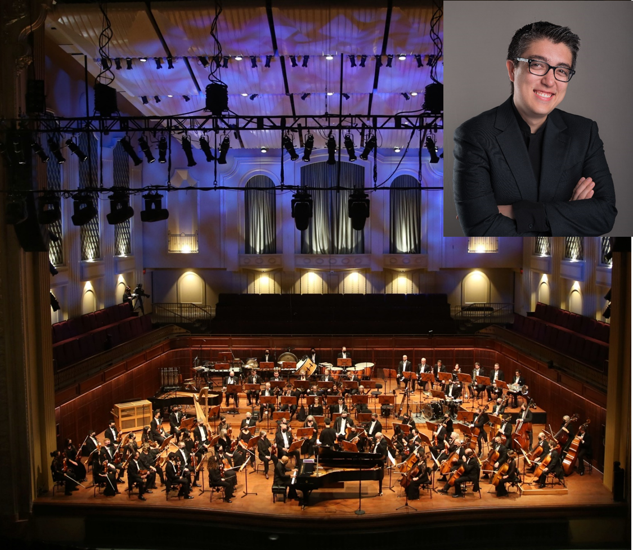

Conductor Ryan, Paul He, and the orchestra will perform “Allegro” from Concerto no. 1 in D minor by Johann Sebastian Bach

(Yo-hahn Seb-as-chun Bakh)
Click here to listen to the piece on Spotify.

Conductor Ryan and the orchestra will perform An American in Paris by George Gershwin

Click here to listen to the piece on Spotify.

Conductor Ryan and the orchestra will perform
“Olympic Fanfare and Theme” by John Williams

Click here to listen to the piece on Spotify.



When the performance is over, I can use the ASL sign for applause or clap to thank the conductor and the musicians.



I will wait in my seat until it is time for my group to return to school.

When I get home, I can share what I heard and saw at the symphony with my friends and family.

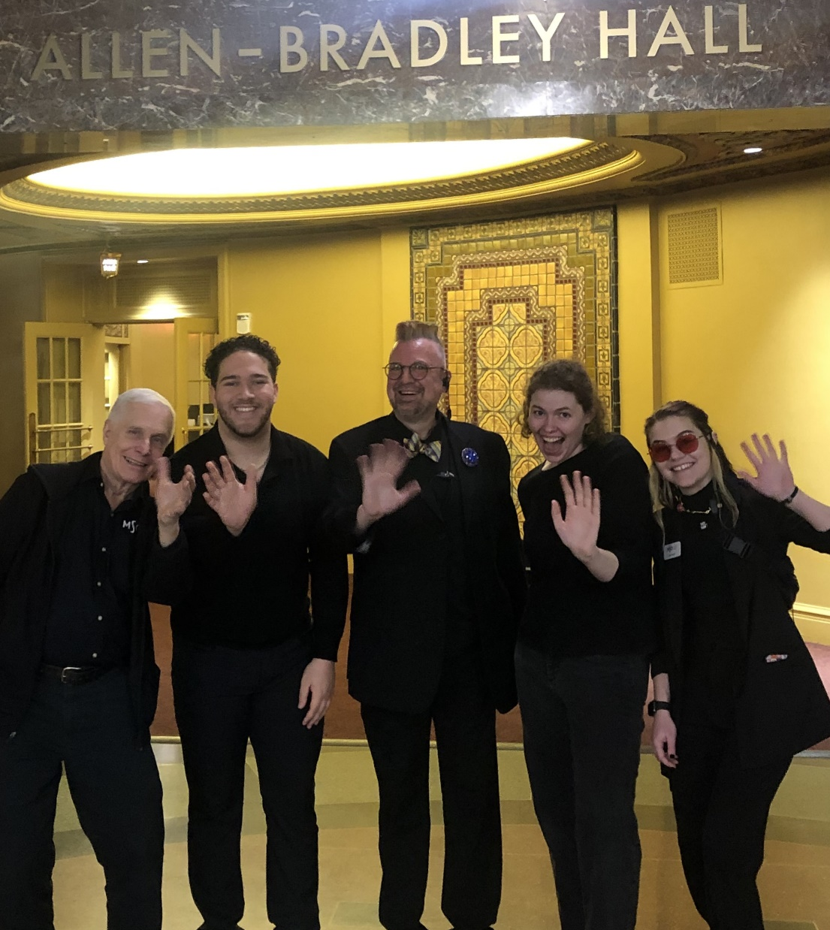

The Milwaukee Symphony Orchestra musicians and staff are so happy you came to the performance today. They look forward to seeing you again!

