Vibrant Vivaldi
Social Narrative

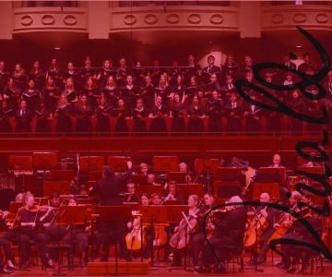


Welcome to the Milwaukee Symphony Orchestra Vibrant Vivaldi Concert!

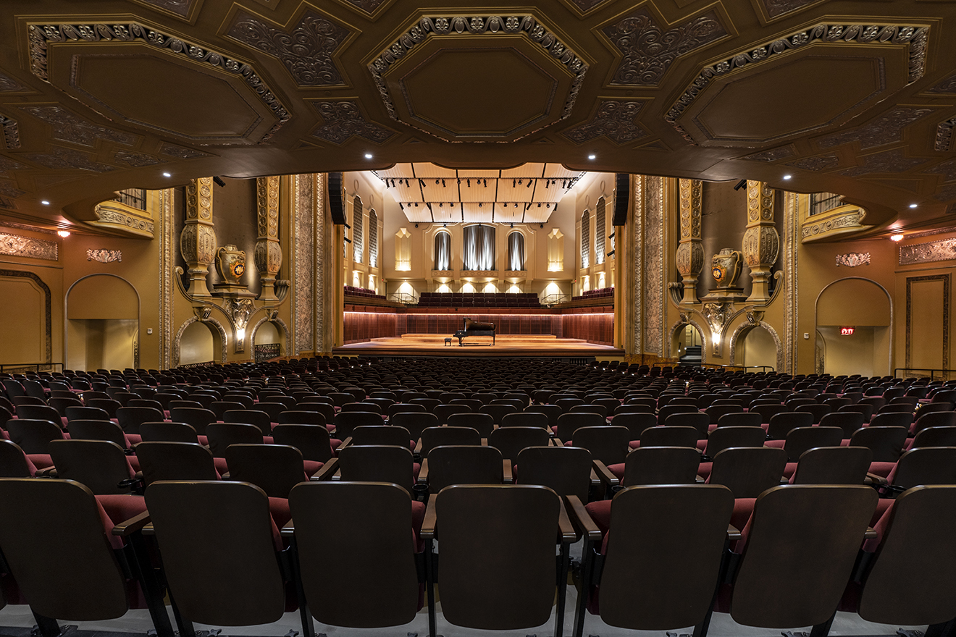

Before the concert begins, I will find my seat with my school in Allen-Bradley Hall!



Associate Conductor Ryan Tani will be our maestro for today’s performance.





The sounds the orchestra makes will sometimes be loud.

Even though the sounds can be loud and can feel scary, none of the noises can hurt me.

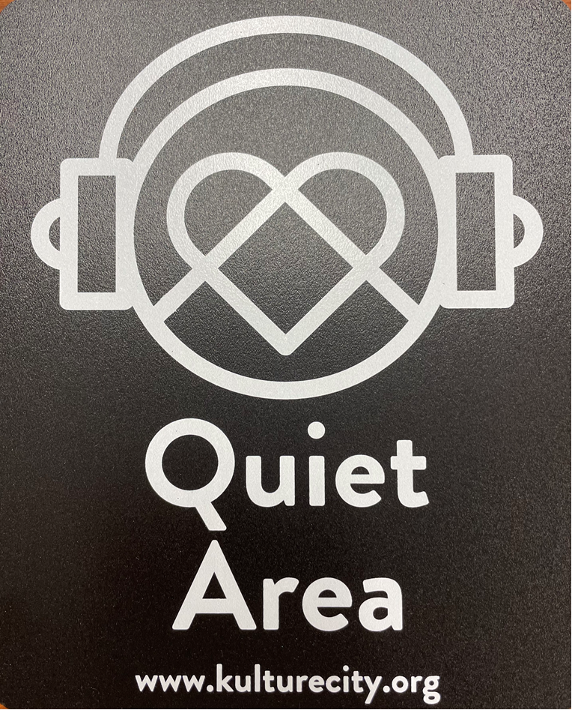
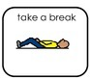

If I need to take a break, I can leave and come back at any time.


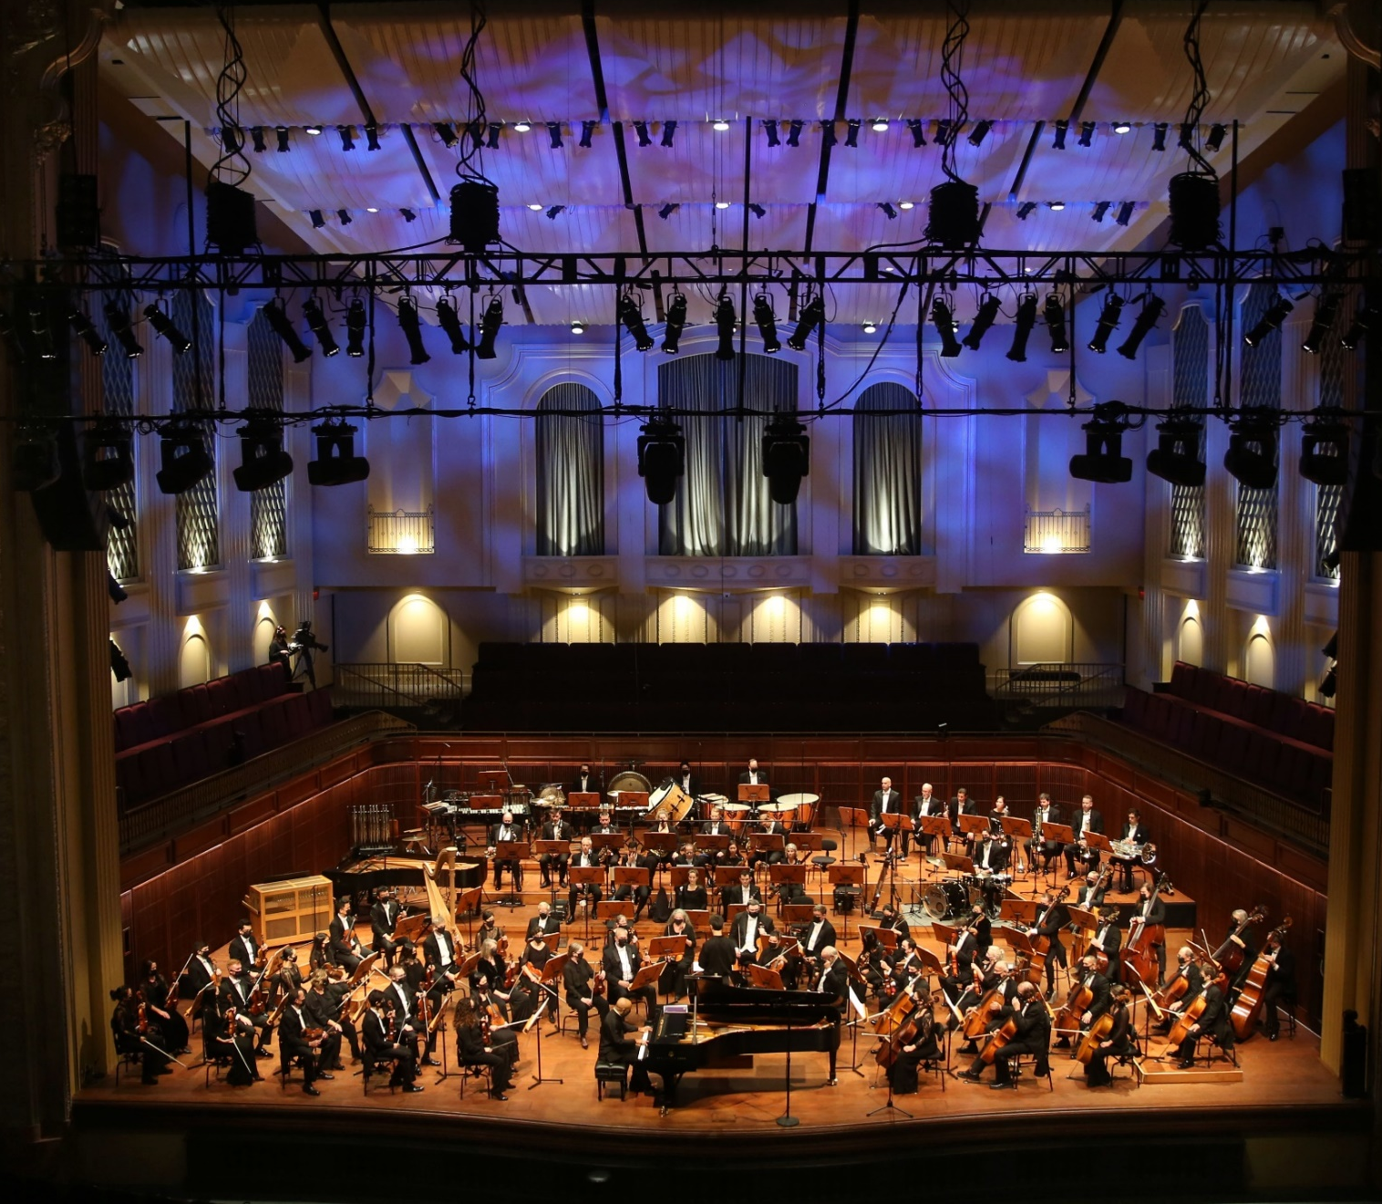

Associate Conductor Ryan and the orchestra will perform the Holberg Suite by Edvard Grieg, movements 1, 2, and 5.

(WHOLE-burg Sweet) (ED-vaard Greeg)


Click here to listen to the piece on Spotify.

Associate Conductor Ryan, the orchestra, and the Teen Choral Partners will perform Gloria by Antonio Vivaldi.

(GLORE-ee-ah) (Ann-TONE-ee-oh Viv-ALL-dee)

Click here to listen to the piece on Spotify.

.
Associate Conductor Ryan, the orchestra, and the Teen Choral Partners will perform Zadok the Priest by George Frideric Handel.

(Zay-DOCK the Preest) (George FREED-rick HAND-ell)

Click here to listen to the piece on Spotify.



When the performance is over, I can use the ASL sign for applause or clap to thank the conductor and the musicians.



I will wait in my seat until it is time for my group to return to school.

When I get home, I can share what I heard and saw at the symphony with my friends and family.

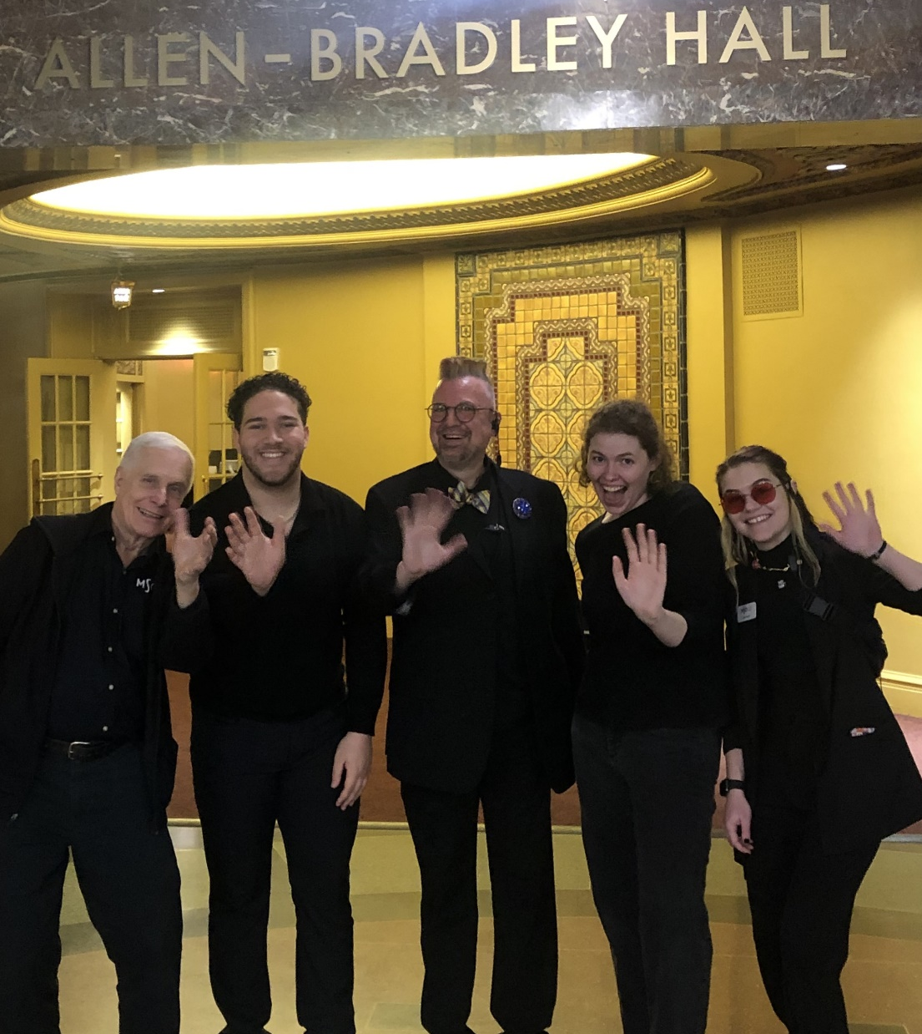

The Milwaukee Symphony Orchestra musicians and staff are so happy you came to the performance today. They look forward to seeing you again!

