Peter and the Wolf

Social Narrative





Welcome to the Milwaukee Symphony Orchestra Peter and the Wolf Concert!

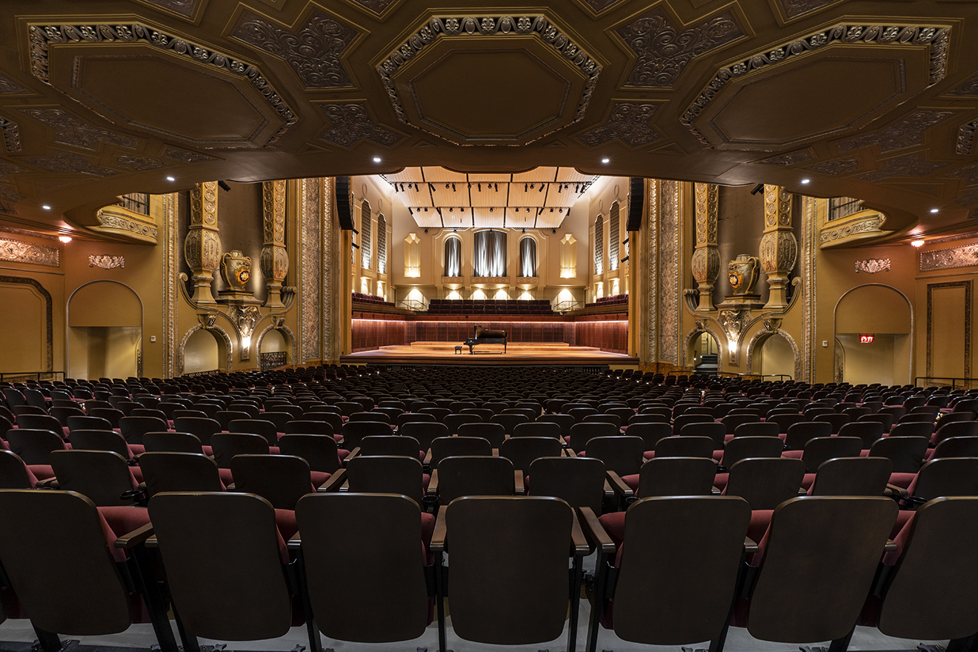

Before the concert begins, I will find my seat with my school in Allen-Bradley Hall!



Assistant Conductor Ryan Tani will be our maestro for today’s performance.



Really Inventive Stuff will be our narrators for today’s performance.





The sounds the orchestra makes will sometimes be loud.

Even though the sounds can be loud and can feel scary, none of the noises can hurt me.

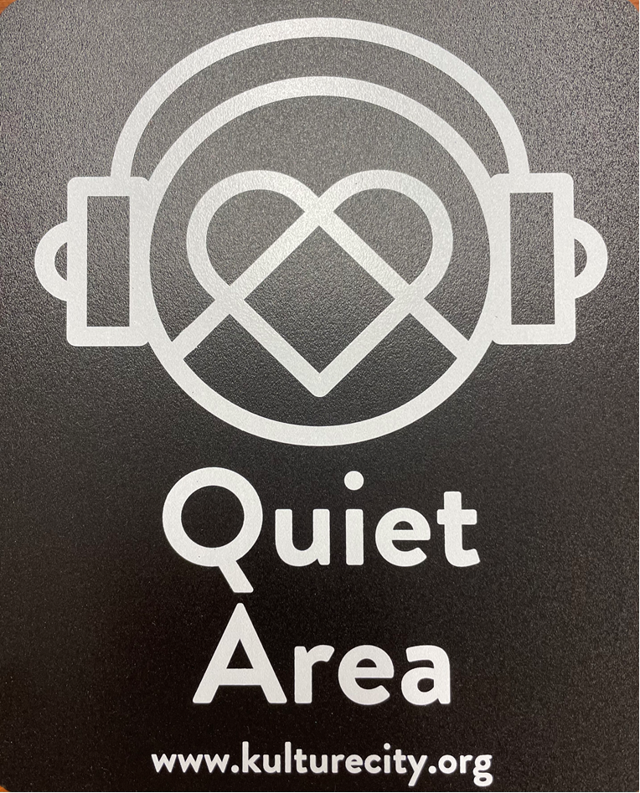
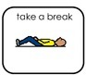

If I need to take a break, I can leave with a chaperone and come back when I’m ready.


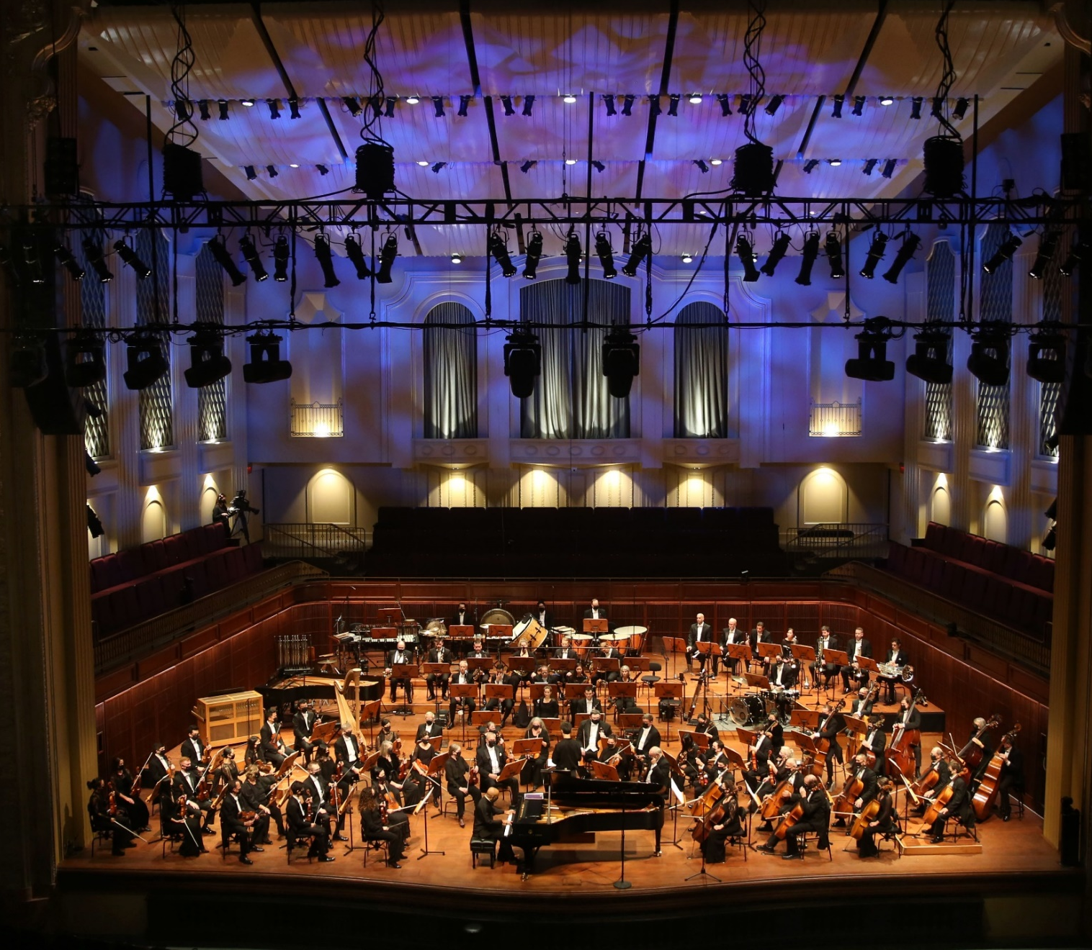

Conductor Ryan, Really Inventive Stuff and the orchestra will perform
How to Escape from the Zoo by Andrew Maxfield

“How to Escape from the Zoo” is currently being written for this performance, so no recordings currently exist.
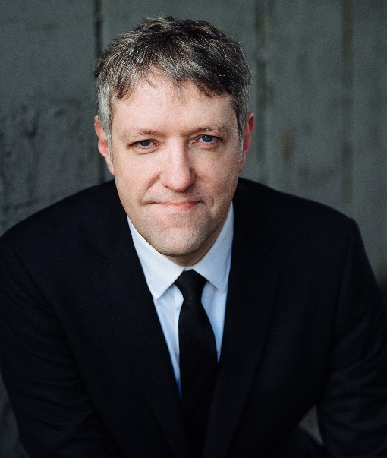
Conductor Ryan, Really Inventive Stuff and the orchestra will perform
Peter and the Wolf by Sergei Prokofiev

(sare-gay pro-koh-fee-ehv)


Click here to listen to the piece on Spotify.



When the performance is over, I can use the ASL sign for applause or clap to thank the conductor and the musicians.



I will wait in my seat until it is time for my group to return to school.

When I get home, I can share what I heard and saw at the symphony with my friends and family.

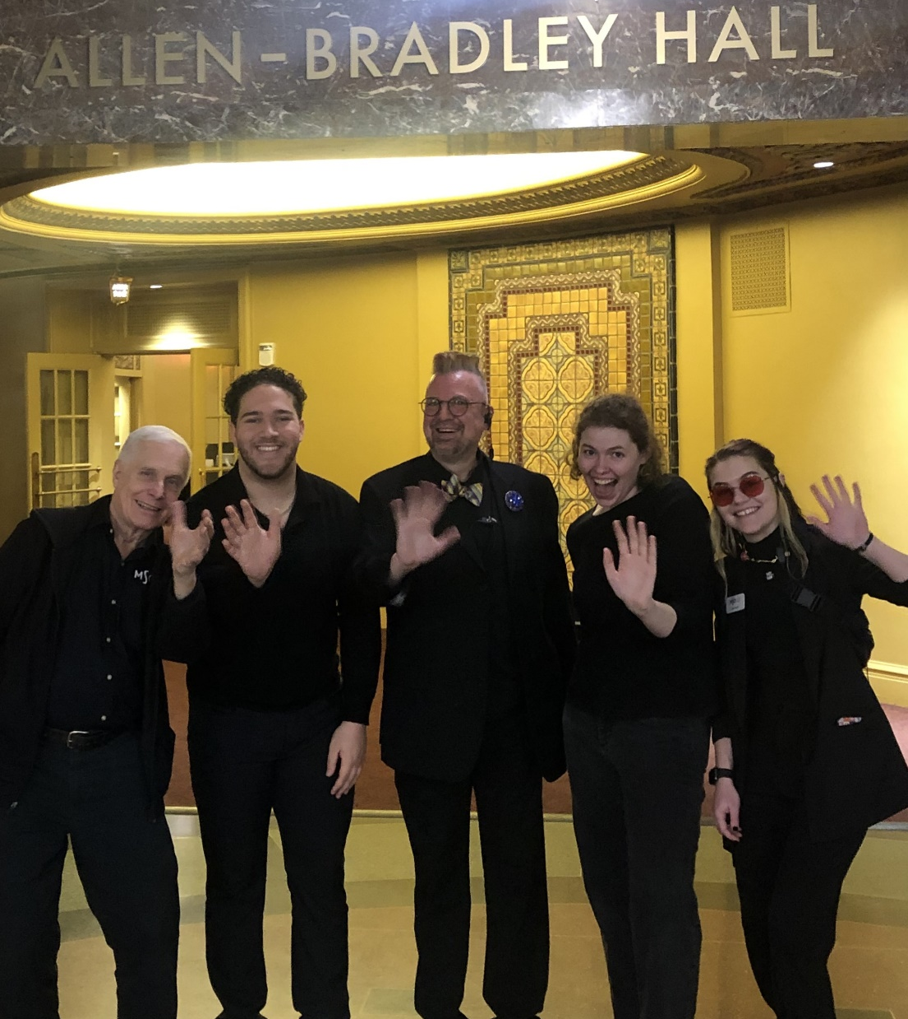

The Milwaukee Symphony Orchestra musicians and staff are so happy you came to the performance today. They look forward to seeing you again!

